****

**WASTE MANAGEMENT SYSTEM**

**NAMES OF THE STUDENTS**

1. **MOHAN RASHIWARNA**
2. **MANIVANNAN SARUNIYA**
3. **HASSIM FATHIMA NAZHATH SHAJIAA**
4. **ANNE SHILPA JESURATHNAM**
5. **HARISHMA JEBARAJAH**

**GROUP D**

**A PROJECT SUBMITTED TO**

**INTERNATIONAL COLLEGE OF BUSINESS AND TECHNOLOGY (ICBT)**

**IN PARTIAL FULFILLMENT OF THE REQUIREMENTS**

**FOR THE**

**HND IN COMPUTER STUDIES**

**May 2018**

**Feedback Form**

**International College of Business & Technology**

**Module:**

**Student:**

**Assessor:**

**Assignment:**

**Strong features of the proposal:**

**Areas for improvement:**

**Marks Awarded:**

**International College of Business and Technology (ICBT)**

Statement of originality of submitted work

Here by confirm that the work presented here in this report, and in all other associated material, done by our own work, and I / we agree to assessment for plagiarism.

StudentNumber&Name

Signature :………………………………………….…………………………

Date :……………………………………………………….……………

# ACKNOWLEDGMENT

First, I would like to thank the Almighty for giving us the strength and knowledge to complete the assignment, and I would like to thank ICBT also for helping me in doing this assignment.

In performing our final project, we had to take the help and guideline of some respected persons, who deserve our greatest gratitude. The completion of this assignment gives us much Pleasure. We would like to show our gratitude to **Lecture panel and ICBT campus** who gave us a good guideline for this project throughout numerous problems. We would also like to expand our deepest gratitude to all those who have directly and indirectly guided us in completing this project.

And, especially we would like to thank our friends who helped us to overcome our problems regarding assignments. We thank each and every one who helped us directly and indirectly to complete our project.

  Group D members

Table of Contents

[1](#_Toc515442182)

[**WASTE MANAGEMENT SYSTEM** 1](#_Toc515442183)

[**A PROJECT SUBMITTED TO** 1](#_Toc515442184)

[**IN PARTIAL FULFILLMENT OF THE REQUIREMENTS** 1](#_Toc515442185)

[Statement of originality of submitted work 3](#_Toc515442186)

[Here by confirm that the work presented here in this report, and in all other associated material, done by our own work, and I / we agree to assessment for plagiarism. 3](#_Toc515442187)

[Signature :………………………………………….………………………… 3](#_Toc515442188)

[Date :……………………………………………………….…………… 3](#_Toc515442189)

[ACKNOWLEDGMENT 4](#_Toc515442190)

[TABLE OF FIGURES 9](#_Toc515442191)

[TABLE OF TABLES 12](#_Toc515442192)

[CHAPTER 01 13](#_Toc515442193)

[Introduction 13](#_Toc515442194)

[Problem Statement 15](#_Toc515442195)

[Literature Review 16](#_Toc515442196)

[Proposed Solution 18](#_Toc515442197)

[Functionalities and non-functionalities of the system 19](#_Toc515442198)

[Functionalities 19](#_Toc515442199)

[Non Functionalities 20](#_Toc515442200)

[Software Development Methodology 22](#_Toc515442201)

[Justification 23](#_Toc515442202)

[CHAPTER 02 24](#_Toc515442203)

[FEASIBILITY REPORT 24](#_Toc515442204)

[Cost feasibility 25](#_Toc515442205)

[Time Feasibility 25](#_Toc515442206)

[Technical Feasibility 26](#_Toc515442207)

[Operational Feasibility 27](#_Toc515442208)

[Requirements Gathering 28](#_Toc515442209)

[Resource Identification 30](#_Toc515442210)

[Hardware resources 30](#_Toc515442211)

[Software resources 30](#_Toc515442212)

[Work Breakdown Structure 32](#_Toc515442213)

[Risk Analysis 36](#_Toc515442214)

[Risk Identification 36](#_Toc515442215)

[Overcome 37](#_Toc515442216)

[CHAPTER 03 38](#_Toc515442217)

[Design of the System 38](#_Toc515442218)

[Database 38](#_Toc515442219)

[Entity Relationship Diagram 38](#_Toc515442220)

[Normalized Relational Schema 40](#_Toc515442221)

[System Design 43](#_Toc515442222)

[UML Diagram 43](#_Toc515442223)

[Use case Diagram 43](#_Toc515442224)

[Class Diagram 44](#_Toc515442225)

[Sequence Diagram 45](#_Toc515442226)

[Pseudo code 48](#_Toc515442227)

[Welcome Page 48](#_Toc515442228)

[Login & Register Page 49](#_Toc515442229)

[Payment Page 50](#_Toc515442230)

[Help & Feedback 51](#_Toc515442231)

[GPRS Page 52](#_Toc515442232)

[Schedule Page 53](#_Toc515442233)

[User Interfaces 54](#_Toc515442234)

[a) Sketch for our mobile Application 54](#_Toc515442235)

[a) User Interfaces of Mobile Application 64](#_Toc515442236)

[c) Wireframe for the website 72](#_Toc515442237)

[d) Designed Pages of the website 76](#_Toc515442238)

[CHAPTER 04 80](#_Toc515442239)

[Explanation of co-functionalities with evidence 80](#_Toc515442240)

[Co functionalities with evidence for dynamic website 91](#_Toc515442241)

[CHAPTER 05 94](#_Toc515442242)

[Testing 94](#_Toc515442243)

[Testing Methodology and Justification 94](#_Toc515442244)

[Test Plan 97](#_Toc515442245)

[Test Cases 99](#_Toc515442246)

[Test Conclusion 112](#_Toc515442247)

[User Manual 113](#_Toc515442248)

[CHAPTER 06 115](#_Toc515442249)

[Limitation 115](#_Toc515442250)

[Lesson learned report 116](#_Toc515442251)

[Future Recommendation 118](#_Toc515442252)

[CONCLUSION 119](#_Toc515442253)

[Strength: 119](#_Toc515442254)

[Weakness: 120](#_Toc515442255)

[Enhancement 120](#_Toc515442256)

[REFERENCES 122](#_Toc515442257)

[APPENDIX 124](#_Toc515442258)

[PLANNED & ACTUAL GANTT CHART 124](#_Toc515442259)

[Estimated Gantt chart 124](#_Toc515442260)

[Actual Gantt chart 126](#_Toc515442261)

[Requirement gathering evidences 129](#_Toc515442262)

[Requirement Gathering Evidences 132](#_Toc515442263)

# TABLE OF FIGURES

[Figure 1 WBS 32](#_Toc515442264)

[Figure 2 ER Diagram 39](#_Toc515442265)

[Figure 3 Relation schema step 1 40](#_Toc515442266)

[Figure 4 Relation schema step 2, 3, 4 41](#_Toc515442267)

[Figure 5 Relation schema step 5 41](#_Toc515442268)

[Figure 6 Relation schema step 6, 7, 8 42](#_Toc515442269)

[Figure 7 Relation schema step 9 42](#_Toc515442270)

[Figure 8 Use case diagram 43](file:///C:\Users\DELL\Desktop\our%20final.docx#_Toc515442271)

[Figure 9 Class diagram 44](file:///C:\Users\DELL\Desktop\our%20final.docx#_Toc515442272)

[Figure 10 Sequence Diagram for Admin 45](#_Toc515442273)

[Figure 11 Sequence Diagram for Worker 46](#_Toc515442274)

[Figure 12 Sequence diagram for User 47](#_Toc515442275)

[Figure 13 Sketxh for Splash page 54](#_Toc515442276)

[Figure 14 Sketxh for welcome page 55](#_Toc515442277)

[Figure 15 Sketch for Driver login page 56](#_Toc515442278)

[Figure 16 Sketxh for Customer login page 57](#_Toc515442279)

[Figure 17 Sketxh for Error sample page 58](#_Toc515442280)

[Figure 18 Sketxh for Map view page 59](#_Toc515442281)

[Figure 19 Sketxh for Map view Mark page 60](#_Toc515442282)

[Figure 20 Sketxh for Navigation drawer page 61](#_Toc515442283)

[Figure 21 Sketxh for Payment page 62](#_Toc515442284)

[Figure 22 Sketxh for Profile page 63](#_Toc515442285)

[Figure 23 UI for Splash page 64](#_Toc515442286)

[Figure 24 UI for Welcome page 65](#_Toc515442287)

[Figure 25 UI for Login page 66](#_Toc515442288)

[Figure 26 UI for Driver Login page 67](#_Toc515442289)

[Figure 27 UI for Customer Login page 68](#_Toc515442290)

[Figure 28 UI for Navigation drawer page 69](#_Toc515442291)

[Figure 29 UI for Map View page 70](#_Toc515442292)

[Figure 30 UI for Map pointed page 71](#_Toc515442293)

[Figure 31 wireframe A 72](#_Toc515442294)

[Figure 32 wireframe B 73](#_Toc515442295)

[Figure 33 wireframe C 73](#_Toc515442296)

[Figure 34 wireframe D 74](#_Toc515442297)

[Figure 35 wireframe E 75](#_Toc515442298)

[Figure 36 Web UI A 76](#_Toc515442299)

[Figure 37 Web UI B 76](#_Toc515442300)

[Figure 38 Web UI C 77](#_Toc515442301)

[Figure 39 Web UI D 77](#_Toc515442302)

[Figure 40 Web UI E 78](#_Toc515442303)

[Figure 41 Web UI F 78](#_Toc515442304)

[Figure 42 Web UI AG 79](#_Toc515442305)

[Figure 43 Web UI H 79](#_Toc515442306)

[Figure 44 Splash code 80](file:///C:\Users\DELL\Desktop\our%20final.docx#_Toc515442307)

[Figure 45 Repositories code 81](file:///C:\Users\DELL\Desktop\our%20final.docx#_Toc515442308)

[Figure 46 Class path code 81](#_Toc515442309)

[Figure 47 Compile 81](#_Toc515442310)

[Figure 48 Navigation code 82](#_Toc515442311)

[Figure 49 Main Activity code 83](file:///C:\Users\DELL\Desktop\our%20final.docx#_Toc515442312)

[Figure 50 Customer Login 1 84](#_Toc515442313)

[Figure 51 Customer Login 2 85](#_Toc515442314)

[Figure 52 Customer Login 3 85](#_Toc515442315)

[Figure 53 Customer Map OnCreate Method 86](#_Toc515442316)

[Figure 54 Customer Map GeoFire 87](#_Toc515442317)

[Figure 55 Customer Map Database 87](#_Toc515442318)

[Figure 56 Customer Map radius 88](#_Toc515442319)

[Figure 57 88](#_Toc515442320)

[Figure 58 88](#_Toc515442321)

[Figure 59 89](#_Toc515442322)

[Figure 60 89](#_Toc515442323)

[Figure 61 90](#_Toc515442324)

[Figure 62 90](#_Toc515442325)

[Figure 63 Web code A 91](#_Toc515442326)

[Figure 64 Web code B 92](#_Toc515442327)

[Figure 65 Web code C 92](#_Toc515442328)

[Figure 66 Web code D 93](#_Toc515442329)

[Figure 67 Web code D 93](#_Toc515442330)

[Figure 68 124](file:///C:\Users\DELL\Desktop\our%20final.docx#_Toc515442331)

[Figure 69 125](#_Toc515442332)

[Figure 70 126](#_Toc515442333)

[Figure 71 127](#_Toc515442334)

[Figure 72 128](#_Toc515442335)

[Figure 73 Requirement gathering survey 129](#_Toc515442336)

[Figure 74 Requirement gathering survey 130](#_Toc515442337)

[Figure 75 Requirement gathering survey 131](#_Toc515442338)

[Figure 76 132](#_Toc515442339)

[Figure 77 133](#_Toc515442340)

[Figure 78 134](#_Toc515442341)

[Figure 79 135](#_Toc515442342)

[Figure 80 136](#_Toc515442343)

[Figure 81 137](#_Toc515442344)

[Figure 82 138](#_Toc515442345)

[Figure 83 139](#_Toc515442346)

[Figure 84 140](#_Toc515442347)

[Figure 85 141](#_Toc515442348)

[Figure 86 142](#_Toc515442349)

# TABLE OF TABLES

[Table 1 requirement gathering sample report 29](#_Toc515442350)

[Table 2 Work break down structure 35](#_Toc515442351)

[Table 3 Test Plan 97](#_Toc515442352)

[Table 4 Test Case 1 99](#_Toc515442353)

[Table 5 Test Case 2 100](#_Toc515442354)

[Table 6 Test Case 3 101](#_Toc515442355)

[Table 7 Test Case 4 102](#_Toc515442356)

[Table 8 Test Case 5 103](#_Toc515442357)

[Table 9 Test Case 6 104](#_Toc515442358)

[Table 10 Test Case 7 105](#_Toc515442359)

[Table 11 Test Case 8 106](#_Toc515442360)

[Table 12 Test Case 9 107](#_Toc515442361)

[Table 13 Test Case 1 0 108](#_Toc515442362)

[Table 14 Test Case 1 1 108](#_Toc515442363)

[Table 15 Test Case 1 2 109](#_Toc515442364)

[Table 16 Test Case 1 3 110](#_Toc515442365)

[Table 17 Test Case 1 4 111](#_Toc515442366)

[Table 18 Lesson learned report 116](#_Toc515442367)

# CHAPTER 01

## Introduction

Waste production is an integral part of human activity and its management can be a huge problem. Waste Management System is collecting, transporting, processing or converting the remaining of anything into some useful product or disposing the collected waste in such a way that is not harmful to the environment. This system is intended for individuals who are stuck in an unfortunate situation to arrange their home waste things. Our waste management system impacts the wellbeing and condition of our general public. The identification, checking and management of waste is one of the key issues of the present. The way it was done in those days of physically observing the losses in wastes bins uses more human exertion, time and cost which can without much of a stretch be avoided with our present innovations. Our application gives a real time indicator of the rubbish level in a trashcan at any given time. By having that information, we would then be able to advance waste gathering routes and in the end reduce fuel utilization. It sanctions waste gatherers to design their everyday/weekly get plan. It’s capable, adaptable, and simple to utilize and is designed and developed to convey genuine possible advantages to individuals. There is high potential for efficient waste management and re-usage of materials to result in higher economic value and cost savings for organizations.

Waste has become a major consequence of modernization and economic development. Waste from any material which comes from domestic, commercial and industrial source emerging from human activities which has no incentive to individuals who have it and is discarded as useless. In early days, waste disposal did not act trouble like homes were spare land was plentiful. Waste disposal became problematic with the rise of towns and cities where large numbers of people gazed to assemble in moderately little territories in quest for jobs. While generation increased, the available land for waste disposal decreased proportionately. Waste management system thus emerged as an essential specialized sector for keeping cities healthy and livable. In the light of this, waste management system is an important environmental health service, and an integral part of basic urban services. This is because, the health implication of poor waste management system can be exceptionally harming to the people exposed to these unsanitary conditions.

Sicknesses, for example, cholera, typhoid, dysentery and malaria are all relates to the practice of poor waste management. This can result in the loss of human resource required in the development of the country.

Likewise, a website has been propelled by our organization keeping in mind the end goal to give a short portrayal for the users to comprehend about our application and to make it easy to understand. By interfacing with us, the users can arrange their trash without making any issue the users and to the environment. By consuming this strategy, the gathering of waste at every regular citizen s house in the city ends becomes easier. Additionally, with the assistance of innovation (GPS) we can manage the dump trucks in choosing the most limited way for refuse accumulation. This undertaking can add an edge to the earth meaning to get savvy and user friendly.

## Problem Statement

Sri Lanka, a developing nation, is facing a severe problem of Municipal Solid Waste management, the currently adopted predominant method being open dumping due mainly to low cost and less processing involved. In contrast, composting is considered to be one of the most technically appropriate methods of managing MSW in Sri Lanka, the composition of waste being predominantly organic.

This problem is arising because lack of infrastructure a lack of resources and absence of proper unseated disposal provisions. Because of these problem people dumping their garbage waste in their convenient place such as road side or some natural area. Waste materials are scattered in road side this will attract all kinds of animals. Cattle and goats will ingest the plastic bags etc. It may damage their health some animals like dogs, crows and monkeys will spread the waste this is also because of people scattering the waste garbage in the road side.

Because of this problem tourist attraction sites and name hotels spreading more and more money to rename their garbage waste in their immediate surroundings. Mostly the seated and dumped garbage often ends up in the damage channels and other waterways which will results in pollution and also disposal the waterfowl. Distinction of water flow ends in flooding during the rainfall periods. And at last it causes stagnant pools to be formed, afterward which again form a perfect habitat for various diseases vectors. One average resident will produce seven and half pound of garbage every day, and that garbage will be basically down in landfills and litters lands coating a great amount of money.

Each and every year, millions of rupees are spent picking up litters and more in thrown away in valuable naturals that could be recycled. As humanity develops new technology and equipment the amount of waste also increases day by day. Government representation must contribute to resolving the issues in garbage disposal. as we continue to waste more and more, we are pollution our natural resource and also our world.

## Literature Review

This chapter reviews past studies and system related to waste management and recycling. This is a rare concept and couples of studies have been done to this context which is used for this research.

Digital evaluation and mobile development are carving a new era that affects human behavior and global governance. Inter connectivity and flow of opportunities for cooperation and ways to work. Waste management could not stay unaffected by these changes.

According to Chea Yuan Young (2009), it is essential to the achievement to zero waste that emphasis is concentrated on front-end preventions rather than end-of-pipe (EOP) treatment. Zero waste is primarily based on cleaner production, waste management, the reduction of unnecessary consumption and the affective utilization of waste materials. (Young, 2009)

There are several explanations given by different types of authors regarding waste management system and mobile app. According to Akansha Nema (2011), proper management of biomedical waste is crucial issue for maintaining human health and the environment. The waste generated in the hospitals has the potential for spreading infections and causing diseases. (Nema, 2011)

A research carried out to identify the factors of waste management system and which garbage category we have to consider more.

According to Parnuwat Usapein (2014), Sustainable waste management was introduced more than ten years ago, but it has not yet been applied to the Thai petrochemical industry. (Usapein, 2014)

Similar apps for instance which is a successful app running in several countries thus we got many ideas to conduct this study and also a local app called Citizen for garbage collection in Kalmunai. Due to the non-expertise in using the app less usage led to a failure.

The drawbacks of Citizen App also taken into consideration to conduct this study as well. Therefore, under the philosophy of sustainable waste management. This research aims to apply the reuse and recycle (3R) concept. In this article we can find what users need and in waste management system what we what to include.

Background and user behavior wastes management has been a significant issue in developing countries a so as Srilanka. It is vital to find out a proper waste management system as to promote clean environment as a nation.

## 

## Proposed Solution

The proposed solution implemented in the project has sustainable solutions, options that let us meet our current needs and provide for future generations as well. Our most promising alternatives are waste reduction; keep the cities clean and healthy.

Our waste management system impacts the health and environment of our society. The detection, monitoring and management of wastes is one of the key problems of the present. The old-fashioned way of manually monitoring the wastes in waste bins utilizes more human effort, time and cost which can easily be evaded with our present technologies.

Our application gives a real time indicator of the garbage level in a trashcan at any given time. By having that data, we can then optimize waste collection routes and eventually reduce fuel consumption. It sanctions trash collectors to plan their daily/weekly pick up schedule.

There are a few key points that a user needs to understand in order to use our application. Likewise, the user should know the possible problems caused by litter the place and the depth significance of reuse, recycle and reduce.

We have introduced an application based on waste management system over to make the users throw their litters in an appropriate way and on time, which brings up time consumption and healthy environment.

Also a website has been launched by our organization in order to give a brief description for the users to understand about our app and to make it user friendly. By connecting with us, the user can dispose their garbage without causing any problem to the users and to the environment.

By consuming this method, the collection of waste at each civilian s house in the city becomes easier. It reduces air pollution, traffic flow, man power, time and money. Also with the help of technology (GPS) we can guide the garbage trucks in selecting the shortest path for garbage collection. This project can add an edge to the environment aiming to get smart and people-friendly.

## Functionalities and non-functionalities of the system

### Functionalities

1. Registration
2. Login
3. Payment
4. Schedules
5. Setting
6. Help and feedback
7. DIY videos
8. GPS tracking
9. Online Payment
10. Email validation

**Splash screen:** Splash screen is the user’s first experience of the application.

**Registration & email validation:** Before entering inside the application user should input their details and email, in order to get registered. After entering the email user will get a verification code to be verified.

**Login:** If user is already registered, they can directly login, and can enter inside the application.

**Navigation drawer:** It is an UI panel that shows the application’s main navigation menu. IT will be hidden when not in use. But, appears when the user swipes a finger from the left edge of the screen, the user touches the drawer icon in the app bar.

**Payment:** If the workers do their job (removed the garbage form the place) they need to be paid. In order to charge the users, we need get information about the payment method. Such as credit card or debit card or cash payments. If it is card payment, we need the details about the card to be used.

**QR code payment:** Before using mobile version API in the application we should add the Google play services SDK dependency in our build.gradle.

**Settings:** From settings you can change whatever you want. Like edit profile, address etc.

**Help and feedback:** Here you can rate our workers. And also you can provide the feedback.

**DIY videos:** These videos will be useful for everyone. It’s regarding recycling, which you can do it by yourself.

**GPS tracking:** User can view the worker’s GPS status (moving location of the driver).

### Non Functionalities

1. Attractive interfaces. This attracts the user mostly. Most of them loves colorful interfaces to be used.
2. Mobile applications now and again need to interface with the Device's sensors, for example, GPS, accelerometer, camera and etc. The application must regard the sensor's working qualities, for example, its working range, affectability, accuracy, least surveying and etc.
3. Security. Access security needs address the client worry for how well the framework is protected against unauthorized access. While evoking access security needs, consider needs with respect to client registration, client approval, and client verification.
4. Availability. The user can access the mobile application at any time, but they can request us only in our working hours.
5. Confidentiality is how much the product framework ensures information and enables just authorized access to the information. Confidentiality necessities address the client worry for how well the framework ensures private information and makes it accessible to authorized clients. Customer credit or debit card information entered during the Checkout payment processing will be secured.
6. Efficiency is the degree to which the product framework handles limit, throughput, and reaction time. Efficiency necessities address the client worry for how quick the framework capacities, how productively the framework takes in data sources and giving outputs. Video load time may be changed for each user, because of the varieties of phones, its speed, and internet speed etc.
7. Safety. The safety requirements notice the user concern for how well the system protects people and the environment from harm.
8. Usability is the straightforwardness with which the client can learn, work, get ready information sources and translate through cooperation with a product framework. Client worry for simplicity of learning and utilizing the framework. While inspiring usability necessities, think about requirements with respect to simplicity of passage, simplicity of learning, simplicity of taking care and conceivable measurements. Some videos regarding the system will make easy, to use the system.

## Software Development Methodology

There are so many SDLC (System Development Life Cycle) models. They are waterfall model, Prototyping model, Spiral model, Iterative model, V shaped model and agile model. Within these we have selected waterfall model for our system. The process of this model can give us opportunity to make necessary changes for the system. It is likewise alluded to as a linear-sequential life cycle model.

The Waterfall Model was the primary Process Model to be presented. It is exceptionally easy to understand and use. In a waterfall model, each phase must be finished before the following phase can start and there is no covering in the phases. The Waterfall model is the earliest SDLC approach that was used for software development. This model represents the software development process in a linear sequential flow. This means any stage in the development process starts just if the past stage is finished. In this waterfall model, the stages don't cover (Tutorialpoints.com, 2017).

**Disadvantages of Waterfall Model**

* High amounts of risk and uncertainty.
* No working software is produced until late during the life cycle.
* Not a good model for complex and object-oriented projects.
* Not suitable for the projects where requirements are at a moderate to high risk of changing. So, risk and uncertainty is high with this process model.
* Adjusting scope during the life cycle can end a project.
* It is difficult to measure progress within stages (Tutorialpoints.com, 2017).

**When to use the Waterfall Model**

* This model is used just when the requirements are extremely outstanding, clear and settled.
* Product definition is stable.
* Technology is understood.
* There are no uncertain requirements.
* Abundant assets with required ability are accessible freely.
* The project is short (Tutorialpoints.com, 2017).

### Justification

This waterfall model is very simple to use and also very easy to understand. This model relies on teams following a sequence of steps and never moving forward until the previous phase has been completed. This structure is suited to our project because; our project is smaller project with deliverables that are easy to define form the start. It is the straight forward model and knows in which phase the project is. Testing and the modification are done in the phase, chances of defect multiplication reduced. Low level of entry due to the good adaptability. Easy to arrange all the tasks in a short time period.

Takes into account Early Design Changes, while it can be hard to roll out outline improvements later process, the waterfall approach loans itself well to adjustments ahead of schedule in the life cycle. This is extraordinary while fleshing out the particular archives in the main couple stages with the advancement group and customers, as changes can be attempted, since no coding or usage has really occurred up to that point. Getting the requirements and configuration off the beaten path first likewise enhances quality; it's significantly simpler to get and correct possible flaws at the outline organize than at the testing stage, after every one of the parts have been coordinated and finding particular errors is more complex, but can handle it.

Suited for Milestone-Focused Development, Due to the characteristic direct structure of a waterfall venture, such applications are constantly appropriate for associations or groups that function admirably under a point of reference and date-centered worldview. With clear, cement, and surely knew stages that everybody on the group can comprehend and get ready for, it is moderately easy to build up a course of events for the whole procedure and relegate specific markers and points of reference for each stage and even finish.

# CHAPTER 02

## FEASIBILITY REPORT

This report is the ultimate result of the feasibility study which gives by the feasibility study team. The feasibility report is including many points of interest of the project. Mostly the report delivers the solution of characterized issues.

The introduction is a preview of a detailed report. Its feature the essential purpose of the proposed project details and the introduction help with the ageless people groups to comprehend the entire report. If the general populations don’t have specialization about the project which help to comprehend the project since this is clarify the entire the project shortly? It additionally gives project plus and minus of the project.

The background details of interest are the reasonable perspective of entire project. In here all the project details of interest are clearly explain and it's give project designs and how is the project actualizing amid the project creating period. Which will give clear comprehend to the readers, and who need to think about the entire project.

The outline of the project view is basically given to the advertisers to remain the great coming to in showcase. In here some of project details are given to the advertisers which are project used technology, quality details, and other inputs. It will full think of the project to the clients or market people groups.

The overview of the project imperative it will talk essential purpose of the project. In this part issues are clarifying well and what are the methodologies used to taking care of the issues additionally give in this part. Furthermore, in conclusion the project expects advantages and project benefits are talked about in here and result additionally give. It will make the project proposition in the mind of the readers.

The project conclusion is the last discourse of the project it's given by project group. What's more, here all the principle focuses and proposition are given for the readers. This is the chance to wrap up the project data in a clean bundle and convey it to readers.

### Cost feasibility

Economic feasibility investigation is the most ordinarily utilized technique for deciding the effectiveness of another venture. It is otherwise called taken a toll investigation. It helps in recognizing benefit against venture anticipated from an undertaking. Cost and time are the most fundamental elements associated with this field of study.

We can reach our destination because of nowadays Sri Lanka is facing a big problem in disposing garbage. Neither City nor village everywhere we are facing the same problem, But the system is comparatively small therefore the total cost will be less.

#### Development Cost

The costs an organization brings about in procedure of growing new goods and services to best suit the organization's and customer needs. In here our organization may spend a lot to make the city clean or to make people awareness from garbage related problems. However, make the potential for higher benefits in the medium and long term. Therefore, numerous investigators think of it as a positive sign when organizations give a huge add up to their innovative development costs. We spend Rs.1000 for our project.

#### Implementation Cost

This is the cost the organization has to spend in order to implement the developed system

#### Maintenance Cost

This is the cost organization must spend t maintain the system.

### Time Feasibility

This is the most critical for project achievement; all things considered, a task will flop if not finished on time. In planning possibility, an organization appraises how much time the undertaking will take to finish. At the point when these regions have all been inspected, the plausibility examine recognizes any requirements the proposed undertaking may confront, including:

* Internal Project Constraints: Technical, Technology, Budget, Resource, etc.
* Internal Corporate Constraints: Financial, Marketing, Export, etc.
* External Constraints: Logistics, Environment, Laws and Regulations, etc.

We got nearly two months’ time to complete our system. Once the system is developed, it takes more time to fix bugs and do to the testing process.

### Technical Feasibility

Once the technical feasibility is established it is important to consider the monitory factors also. This feasibility centers on the technical assets accessible to the association. It enables associations to decide if the technical assets meet limit and whether the technical group is fit for changing over the thoughts into working frameworks. Technical feasibility additionally includes assessment of the equipment, programming, and other innovation necessities of the proposed framework.

The resources of our project are mentioned below.

1. Hardware requirements

* Minimum RAM: 1GB
* Processor: Dual Core
* Storage Space: 16GB Minimum
* Minimum RAM: 8GB
* Processor: Core i3
* Ethernet Cable
* DVD-ROM
* Storage Space: 64GB Minimum

1. Software requirements

* Operating System: Android 4.4 or above
* Operating System: Windows 7 or above (Windows 10 preferred)
* System Type: 64bit operating system
* Fire base
* Appropriate network drivers
* Java
* Wireframe

1. Wi-Fi-router – a wireless network device to connect to local area network

### Operational Feasibility

Operational Feasibility this assessment incorporates undertaking an examination to look at and choose if and how well the association's needs can be met by completing the wander. Operational feasibility contemplates furthermore look at how a task design fulfills the prerequisites distinguished in the necessities investigation period of framework improvement.

Here our developers worked to fulfill all the requirements of users but we had to work with a dead line time frame.

Operational feasibility concerned with whether the proper resources exist or reasonably attainable to implement a specific alternative. This includes the garbage collecting, existing and available utilities, processing mobile app handling equipment, quality requirements and skill level of workers. During this process, mobile application specifications and facility constraints should be taken into account.

* Safety for customer.
* Compatibility with current work process.
* Impact on mobile application quality.
* Knowledge and skills required to operating and maintain the alternative.
* Implementation workers.

## Requirements Gathering

There are some requirements gathering methods,

* Interviews
* Observations
* Questioner
* Document Review
* Website Visit

I used Survey for gather requirements. A survey is a process of gathering data that could involve a wide variety of data collection methods, including a questionnaire.

**I use survey because,**

* Questionnaires are cost efficient

Questionnaires are one of the most affordable ways to gather quantitative data. Especially online and mobile survey has very low cost.

* They are practical

Questionnaires are practical way to gather data. They can target group of your choosing and managed various ways. We can pick and choose the questions asked as well as the format (Open ended or close ended). They offer a way to gather vast amount of data.

* Speedy result

It’s quick and easy to collect results with online and mobile tools. We can get summarized response quickly.

* No pressure

When using mail-in, online or email questionnaires, there’s no time limit. Respondents can take their time to complete the question.

I used **email questionnaires** because,

They can be sent out quickly and turnaround can be relatively short.

User responses can be preceded, eliminating transcription errors. The data is already in an electronic format, allowing for easy analysis.

This is our requirements gathering report. We attached this full report with this document in last.

Table 1 requirement gathering sample report

|  |  |
| --- | --- |
|  |  |

## Resource Identification

To develop a system, there has to be proper resources to do it. The resources have to be identified and then implemented during the development of the system. For waste management system, many resources were used and they are given below.

### Hardware resources

1. **Laptops –** this will be used to develop the android application using Android studio. Moreover, the database will be stored in the laptop and will be used as a server for the application. (Core i5 processor, 8GB DDR4 Ram, 1TB HDD, 8th Generation Laptop)
2. **Android Devices** – this will be used to run the android application which will be developed and will be used to test the android application during the development stage. (phones)
3. **Wi-Fi router** – this will be used to make connections between the android application and the desktop application with the database server. (50GB Package)
4. **1 TB Transcend**

### Software resources

1. **Windows 10** –this operating system will be used to run the desktop application, most importantly develop the applications. (64-bit OPS)
2. **Android studio –**this will be used to develop the android app using JAVA. (Version 2.3)
3. **MS Office** –this will be used to do certain documentations.
4. **Firebase**-It is a back end platform for connect with android application. It offers real time database, different APIs, multiple authentication types and hosting platform**.**
5. **Adobe Dreamweaver-** Its enables the HTML programmer to build complex website using HTML, JavaScript and server-side programming language. We used Dreamweaver for create our website.
6. **Wireframe-** It’s known as page schematic or screen blueprint, is a visual guide that represent the skeletal framework of a website. We used wireframe to draw our website interface skeletal.
7. **Sketch Up**- Is a 3D modeling computer program for a wide range of drawing applications such as architectural, interior design, landscape architectural, civil and mechanical engineering.

## Work Breakdown Structure

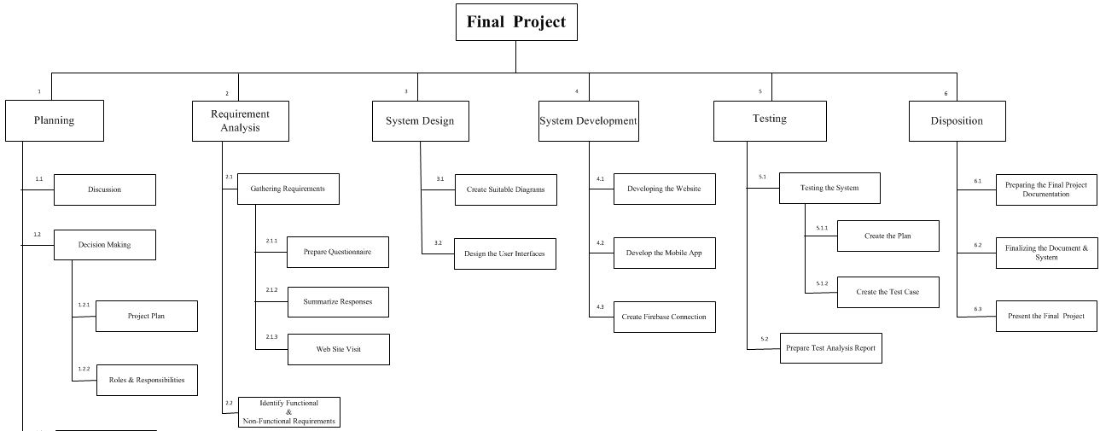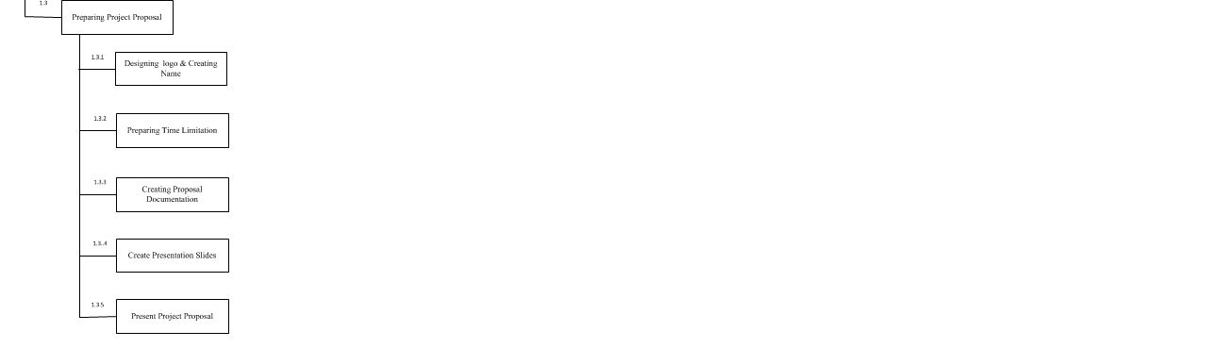

Figure 1 WBS

|  |  |  |  |  |
| --- | --- | --- | --- | --- |
| **Task No** | **Task Name** | **Dependencies** | **Duration** | **Resources** |
| 1 | Planning |  | 1day | Meeting Room,Paper,Pen |
| 1.1 | Discussion | 1 | 1day | Meeting Room, Table,  Chair, Pen,Paper,Pencil |
| 1.2 | Decision Making | 1.2 | 1day | Paper,Pen,Pencil,Eraser,  Ruler |
| 1.2.1 | Project Plans | 1.2 | 1day | Paper,Pen,Pencil,Eraser,  Ruler |
| 1.2.2 | Roles & Responsibilities | 1.2 | 3days | Meeting Room,Paper,Pen |
| 1.3 | Preparing Project Proposal | 1.2 | 1day | MeetingRoom, Laptop,Wifi,Pen,Paper,Pencil, |
| 1.3.1 | Designing Logo & Creating Name | 1.2 | 1day | MeetingRoom, Laptop,Wifi,Pen,Paper,Pencil, |
| 1.3.2 | PreparingTime Limitation | 1.2 | 5hours | MeetingRoom, Laptop,Wifi,Pen,Paper,Pencil, |
| 1.3.3 | Creating Proposal Documentation | 1.3 | 5hours | MeetingRoom, Laptop,Wifi,Pen,Paper,Pencil, |
| 1.3.4 | Create Presentation Slides | 1.3 | 2days | Laptop,Wifi,Pen,Paper,Pencil, |
| 1.3.5 | PresentProject Proposal |  | 2days | MeetingRoom, Laptop,Wifi,Pen,Paper,Pencil, |
| 2 | Requirement Analysis | 1.3 | 7days | Laptop,Wifi,Paper,Pen |
| 2.1 | Gathering Requirement | 1.3 | 4days | Laptop,Wifi,Paper,Pen |
| 2.1.1 | Prepare Questionnaire | 1.3 | 2day | Laptop,Wifi,Paper,Pen |
| 2.1.2 | Summarize Responses | 2.1.1 | 1day | Laptop,Wifi,Paper,Pen |
| 2.1.3 | Website Visit | 1.3 | 1day | Laptop,Wifi |
| 2.2 | Identify functional &  Non-Functional Requirement | 1.3 | 2day | Laptop,Wifi,Paper,Pen |
| 3 | System Design |  | 10day | Paper,Pen,Pencil,Eraser,  Ruler, Laptop,Wifi |
| 3.1 | Create Suitable Diagram | 1.3 | 3days | Paper,Pen,Pencil,Eraser,  Ruler, Laptop,Wifi |
| 3.2 | Design the User Interfaces | 3.1 | 7day | Paper,Pen,Pencil,Eraser,  Ruler, Laptop,Wifi |
| 4 | System Development |  | 20day | Laptop,Wifi |
| 4.1 | Developing the Website | 3.2 | 5days | Laptop,Wifi |
| 4.2 | Develop the Mobile App | 3.2 | 12days | Laptop,Wifi |
| 4.3 | Create SQL Connection | 4.2 | 3days | Laptop,Wifi |
| 5 | Testing |  | 2days | Laptop,Wifi |
| 5.1 | Testing the System | 4.2 | 1day | Laptop,Wifi |
| 5.1.1 | Create Test Plan | 4.2 | 5hours | Laptop,Wifi,Paper,Pen |
| 5.1.2 | Create the Test Case | 5.1.1 | 8hours | Laptop,Wifi,Paper,Pen |
| 5.2 | Prepare Test Analysis Report | 5.1 | 1day | Laptop,Wifi,Paper,Pen |
| 6 | Disposition |  | 3days | Laptop, Paper, Pen |
| 6.1 | Preparing the Final Project Documentation | 5.2 | 2days | Laptop, Paper, Pen |
| 6.2 | Finalizing the Document & System | 6.1 | 1day | Laptop, Paper, Pen |
| 6.3 | Present the Final Project | 6.2 | 1day | Laptop,Mobilephone |

Table 2 Work break down structure

## Risk Analysis

### Risk Identification

#### Technical Risks

* A stuck progress bar usually occurs when laptop attempts to reboot from an unexpected shutdown. Such a shutdown occurred due to these three issues:

1. A software fault causing the computer to reboot unexpectedly
2. The power button is continually held down, forcing a shutdown
3. An older battery quickly drains to 0% before the operating system has the opportunity to shut down gracefully (In the previous laptop)

* We got some issues to associate with database in SQL Lite.
* **GPS is not very accurate in giving location because of Error diagnosis of signal failure or signal interference.**
* **We didn’t have enough software’s to complete our final project as majority of the software’s were paid software’s which are expensive.**

#### Schedule

* We almost got two months it was insufficient to complete our project since we wanted any of our project to be useful and resourceful to our society.
* In the middle of these two months we had to complete our assignment, exams and viva as well.

#### Group members

**Strength**

* Solving enormous issues in a short time throughout our project that showed our activeness would lead our undertaking project achievement.
* Strong leadership is important with the team. This doesn’t imply that the leader of our group needs to bully the team to maintain control, where as she did this by defining category or roles to each person.

**Weakness**

* Awful communication. Communication is a vital key building and implementing their roles to the project. If we have an awful communication stuffs like absence of thoughts for individuals and requirements of building the project could end in failure.
* Highly Comparative surroundings without clear and defined group. Must have a clear idea about the projects destination and the solving methods. No clue leads to no where

#### Financial

* 4GB Ram was not sufficient to run android studio. So we bought a new 8GB Ram.

### Overcome

* A stuck progress bar usually occurs. So we had to a buy a new laptop as charge drops down once it gets stocked.
* We faced issues and were very complicated to connect with the database using SQL Lite so we utilized firebase as a solution to this problem to connect with the database.
* **We didn’t have enough software’s so we used alternate software’s to complete the project.**
* **GPS is not very accurate in giving location**

# CHAPTER 03

## Design of the System

## Database

## Entity Relationship Diagram

An Entity Relationship (ER) Diagram is a type of flowchart that illustrates how “entities” such as people, objects or concepts relate to each other within a system.

In ER diagrams the SQL tables are known as entities and the columns will be represented by attributes. The relationships between the database tables can be shown by having a relationship symbol with the relationship ratio in in it. Further, there can be weak entities and weak relationship which can also be shown in the ER diagram. (N.a, 2018)

An ER diagram has been designed for the system of Zero Waste and it is given below.



Figure 2 ER Diagram

### Normalized Relational Schema

This means the mapping of the entity relationship diagram to a relational schema.

There are nine steps in the process of mapping a relational schema and they are given below.

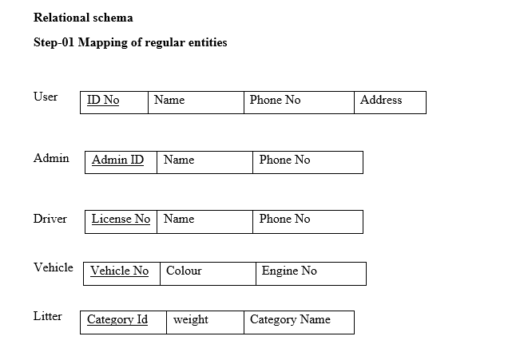

Figure 3 Relation schema step 1

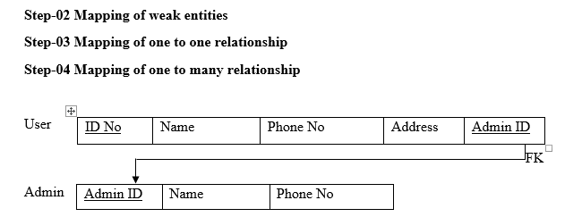

Figure 4 Relation schema step 2, 3, 4

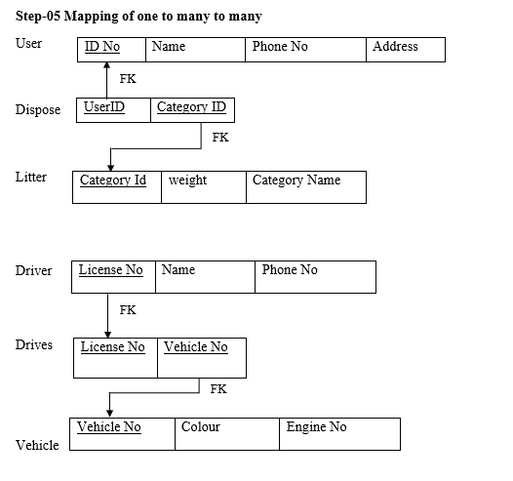

Figure 5 Relation schema step 5

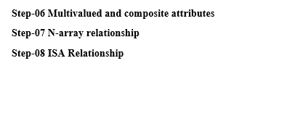

Figure 6 Relation schema step 6, 7, 8

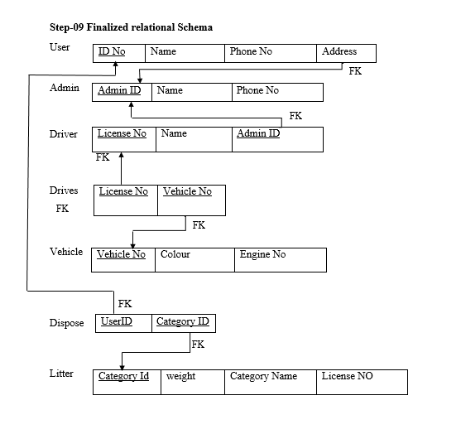

Figure 7 Relation schema step 9

## System Design

## UML Diagram

### Use case Diagram

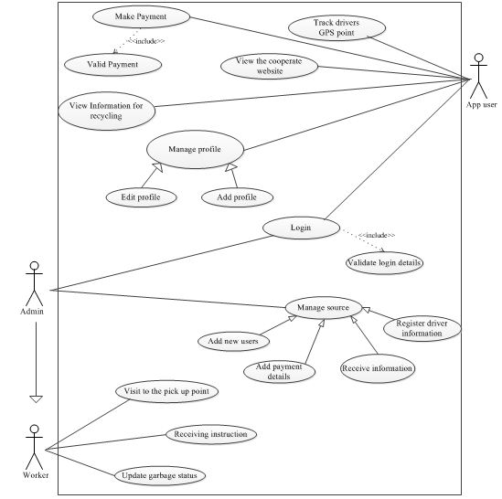

Figure 8 Use case diagram

## Class Diagram

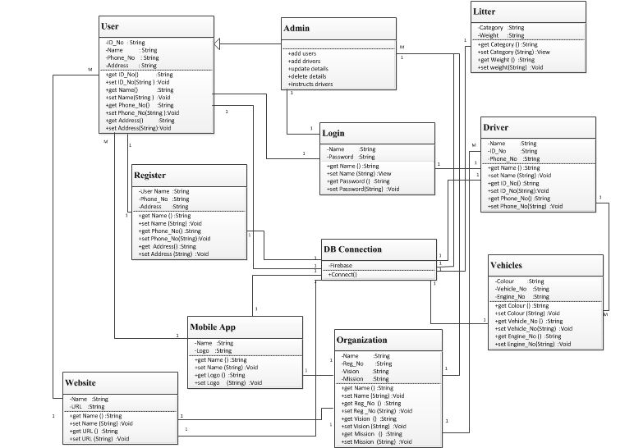

Figure 9 Class diagram

### Sequence Diagram

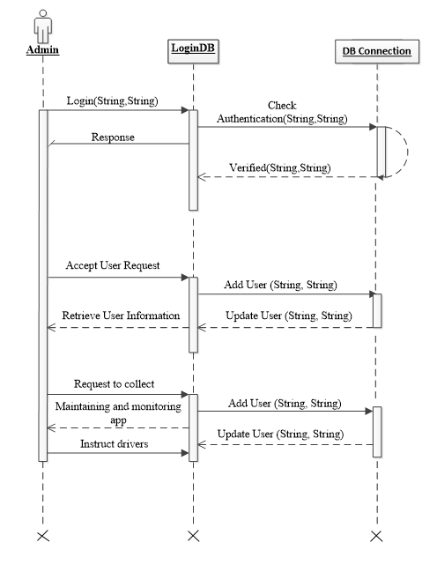

Figure 10 Sequence Diagram for Admin

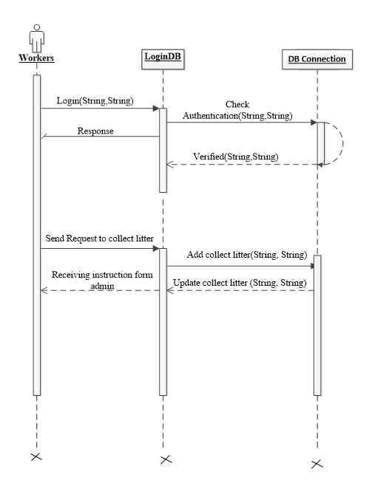

Figure 11 Sequence Diagram for Worker



Figure 12 Sequence diagram for User

## Pseudo code

### Welcome Page

Begin

Select the proper button

If “Am a Customer “button clicked then

{

Display Customer Login Page

}

Else

If “Am a Driver “button clicked then

{

Display Customer Login Page

}

End

### Login & Register Page

Begin

Input “UserMailId” and “Password” textboxes

If “Login” button clicked then

{

Search user in database for user’s member if is not found then

}

{

Display error in page of login “Sign in” start Procedure login again

}

Else

{

If Mail ID or Password correct

}

{

If user =customer then

}

{

Display Application page

}

{

System display Customer page

}

End

### Payment Page

Begin

Select the payment menu

“Display payment page”

If you interest in PayPal method click PayPal input “PayPal Mail ID” and ‘Password”

{

If Mail ID or Password corrected

}

{

Display “Paid Successfully”

}

Else

{

Display Error Message

}

End

### Help & Feedback

Begin

Select the Help & Feedback

If “Rate” tab clicked then

{

Display 5 stars

}

Click Your Ratings

{

Display “Thank You for Your Feedback”

}

Else

If you click the link

{

Display the webpage

}

End

### GPRS Page

Begin

Select the GPS

If location found

{

“Display Map and the Place”

}

Else

{

“Display unfortunately stops”

}

End

### Schedule Page

Begin

Select the schedule menu

{

Display date picker

}

If you want dispose garbage

{

Select the date and category of garbage and click save

}

Then {

Display “Garbage schedule”

}

End

## User Interfaces

### a) Sketch for our mobile Application

We did this sketch in Sketchup application

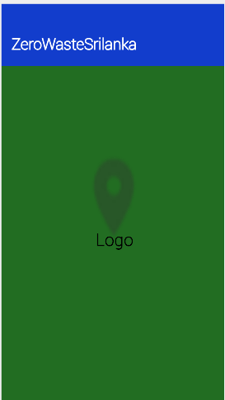

Figure 13 Sketxh for Splash page

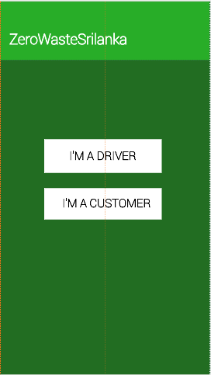

Figure 14 Sketxh for welcome page

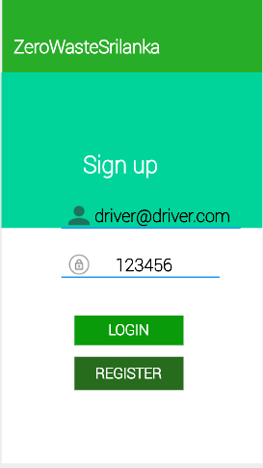

Figure 15 Sketch for Driver login page

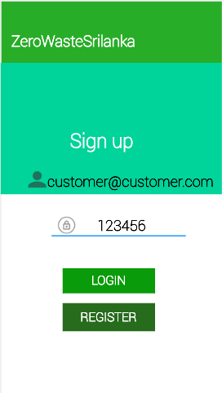

Figure 16 Sketxh for Customer login page

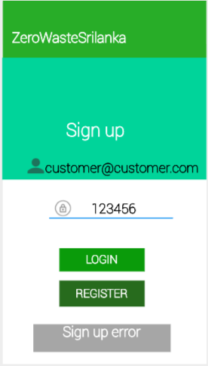

Figure 17 Sketxh for Error sample page

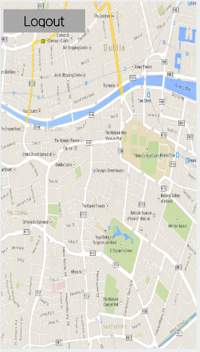

Figure 18 Sketxh for Map view page

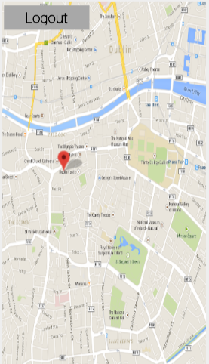

Figure 19 Sketxh for Map view Mark page

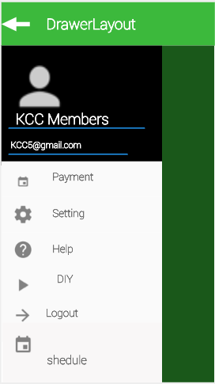

Figure 20 Sketxh for Navigation drawer page

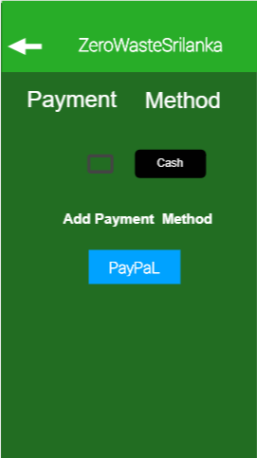

Figure 21 Sketxh for Payment page

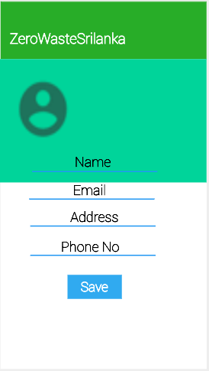

Figure 22 Sketxh for Profile page

### a) User Interfaces of Mobile Application

We designed our user Interfaces as we designed the sketch.

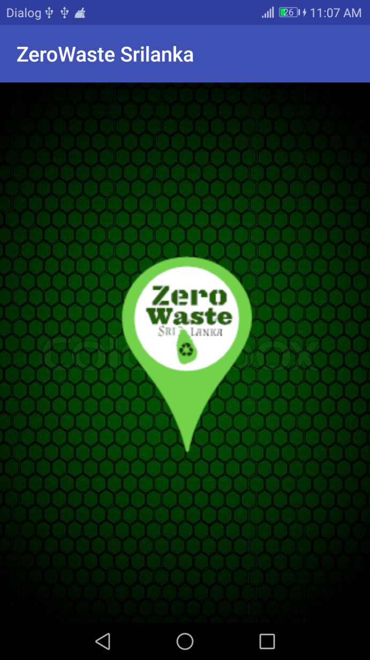

Figure 23 UI for Splash page

Our app name is Zero waste.

Firstly, when your one you will be able to view this splash page. Here we have included our logo.

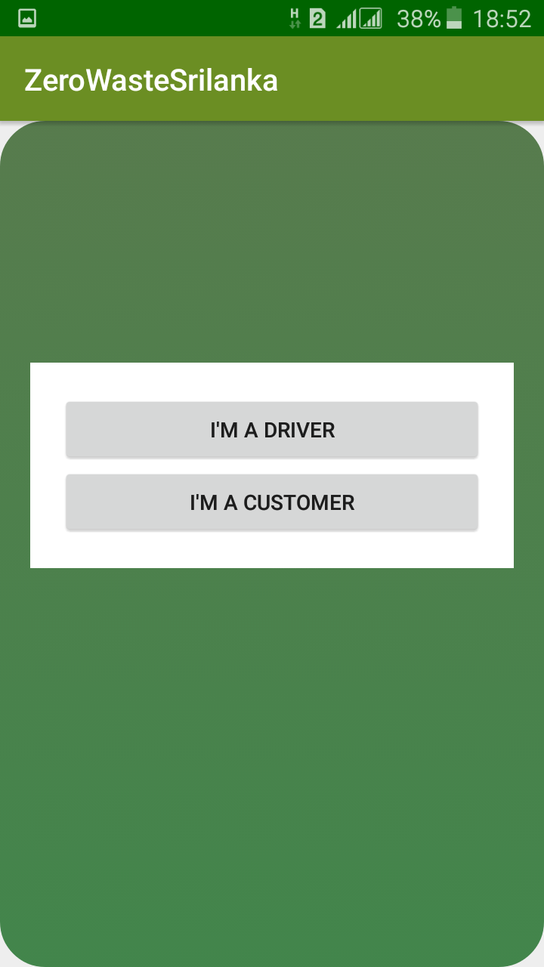

Figure 24 UI for Welcome page

Once the splash page is viewed, you can see this welcome page. User can choose either they are driver or a customer. When you choose any of the button if will take to each different pages

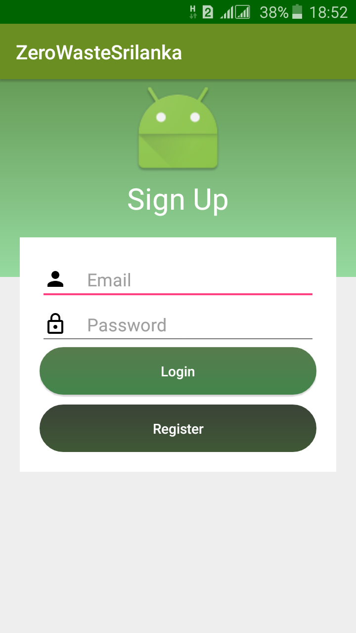

Figure 25 UI for Login page

If you are a new user, you will then have to register yourself an account to login. If you are a member already then you can login anytime. If you try to login before the registration procedure then you will get an error message.

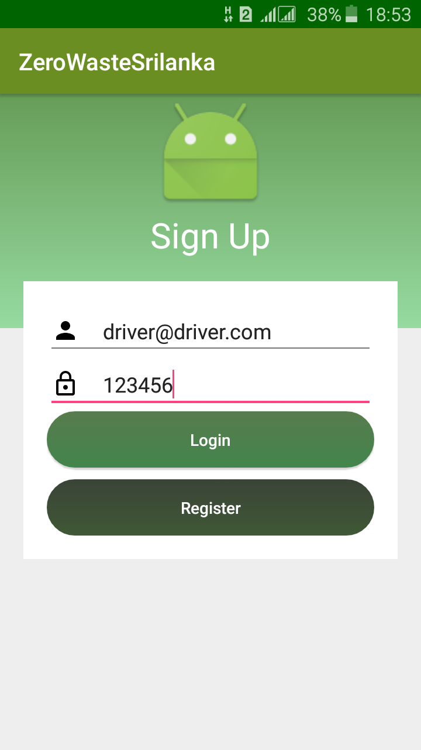

Figure 26 UI for Driver Login page

This is how a driver can login or register them self.

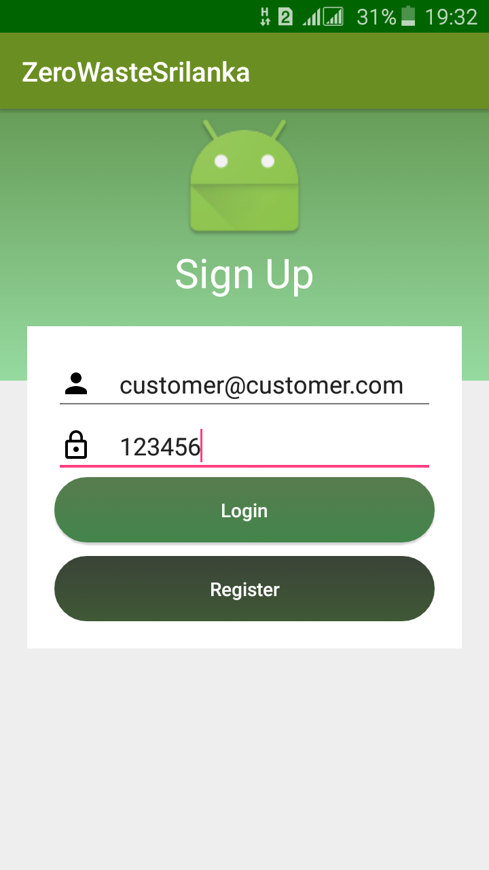

Figure 27 UI for Customer Login page

This is how a customer can login or register them self.

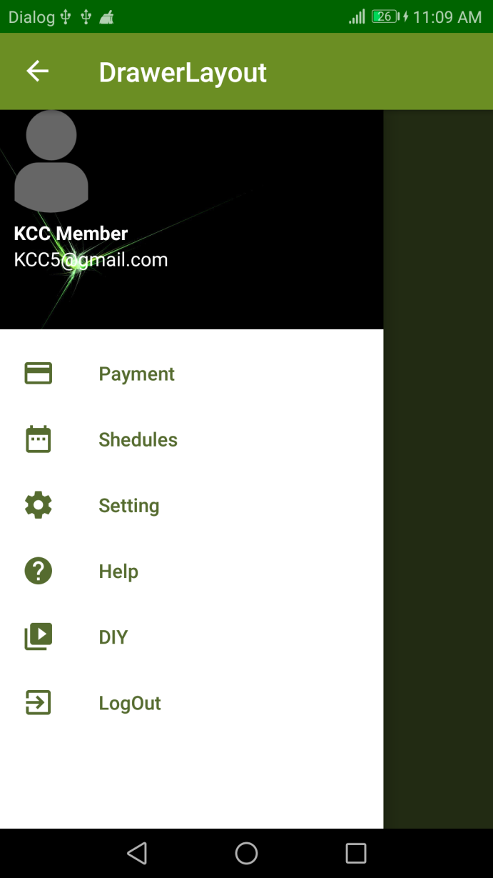

Figure 28 UI for Navigation drawer page

Once the registration procedure or login is done you will be directly taken to this page. Here you find everything clearly.

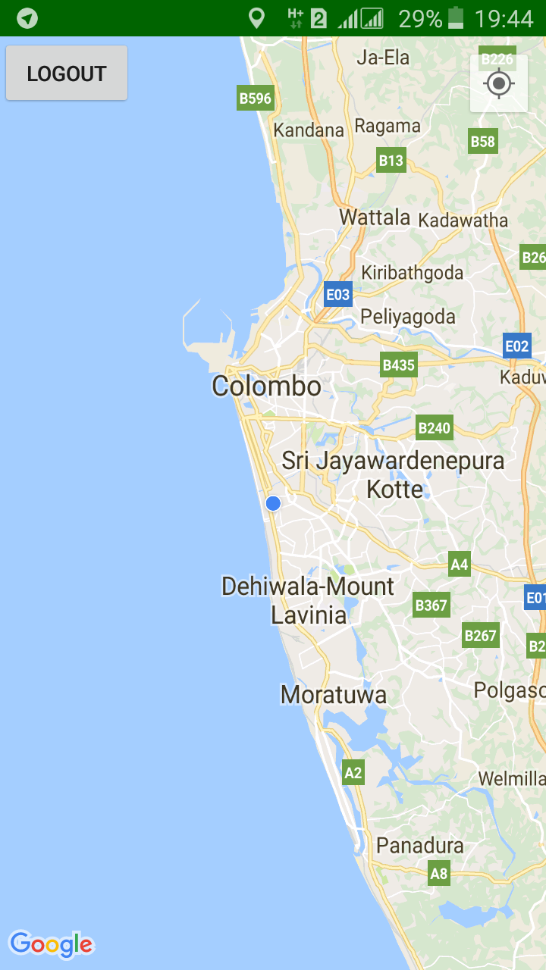

Figure 29 UI for Map View page

This is the map with GPS service to track peoples location.

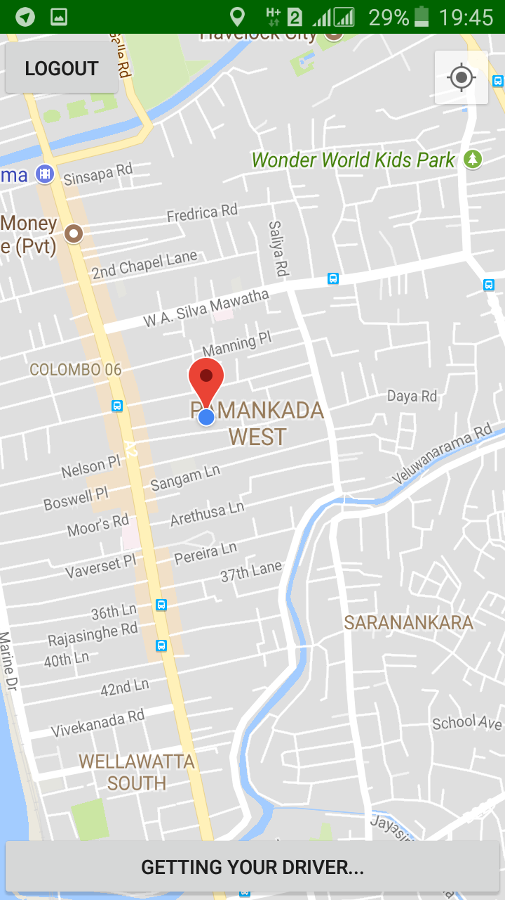

Figure 30 UI for Map pointed page

This page is display which is showing user location to driver.

### c) Wireframe for the website

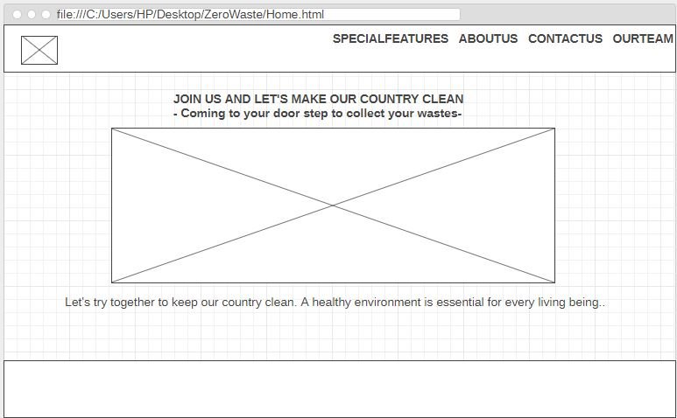

Figure 31 wireframe A

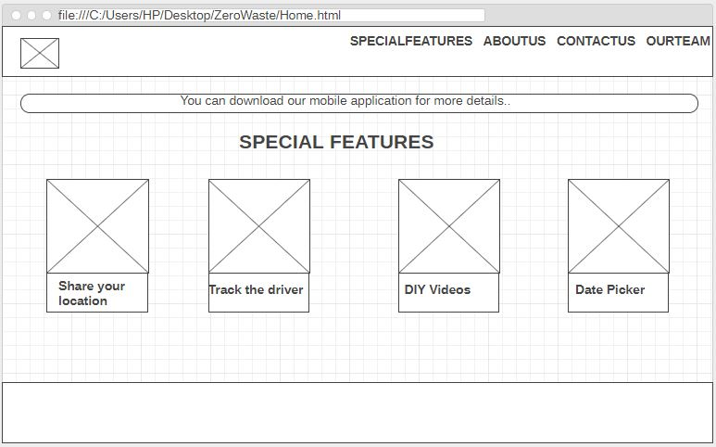

Figure 32 wireframe B

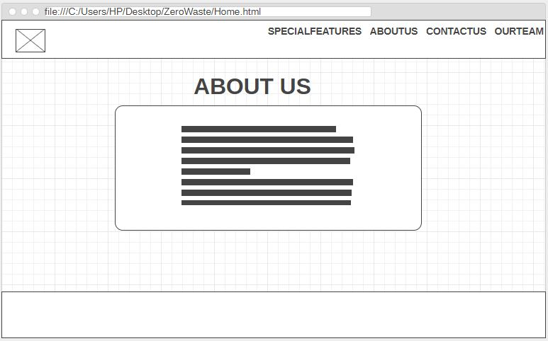

Figure 33 wireframe C

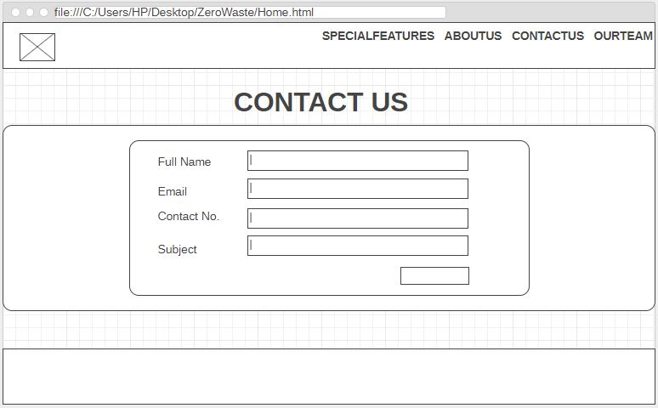

Figure 34 wireframe D

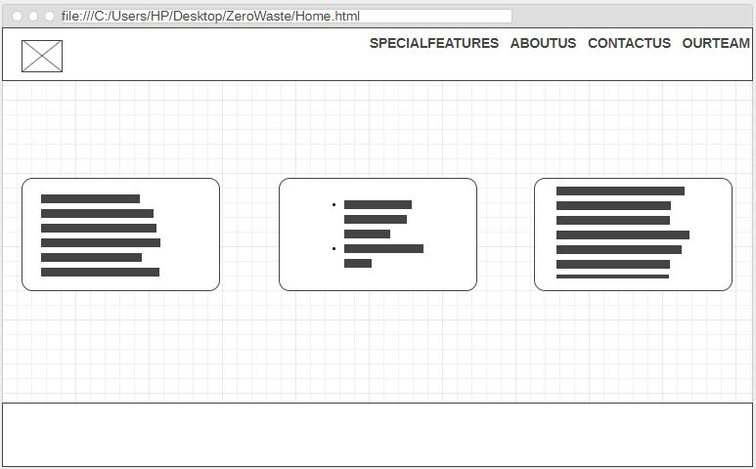

Figure 35 wireframe E

### d) Designed Pages of the website

These are the user interface of our dynamic website.

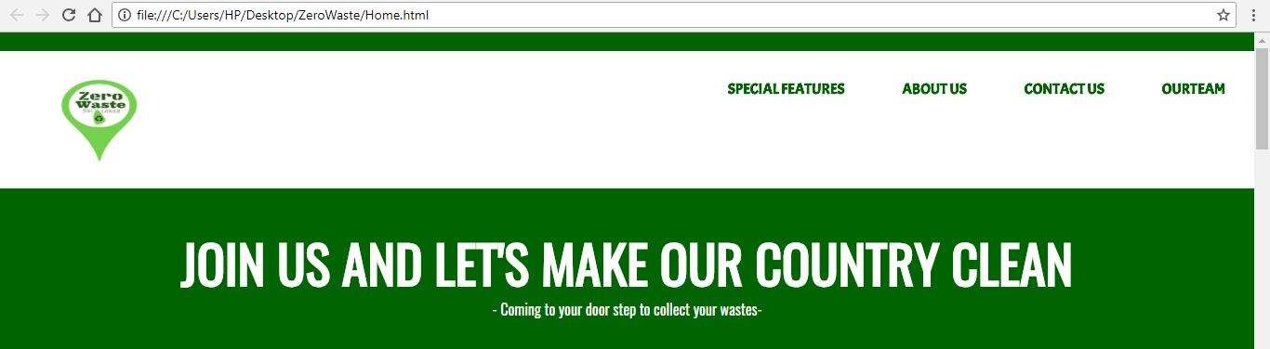

Figure 36 Web UI A



Figure 37 Web UI B

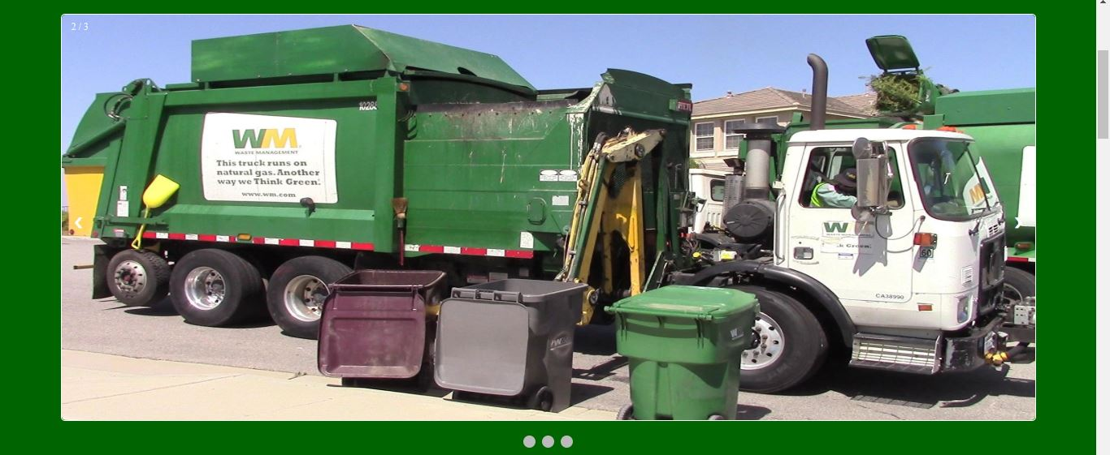

Figure 38 Web UI C



Figure 39 Web UI D

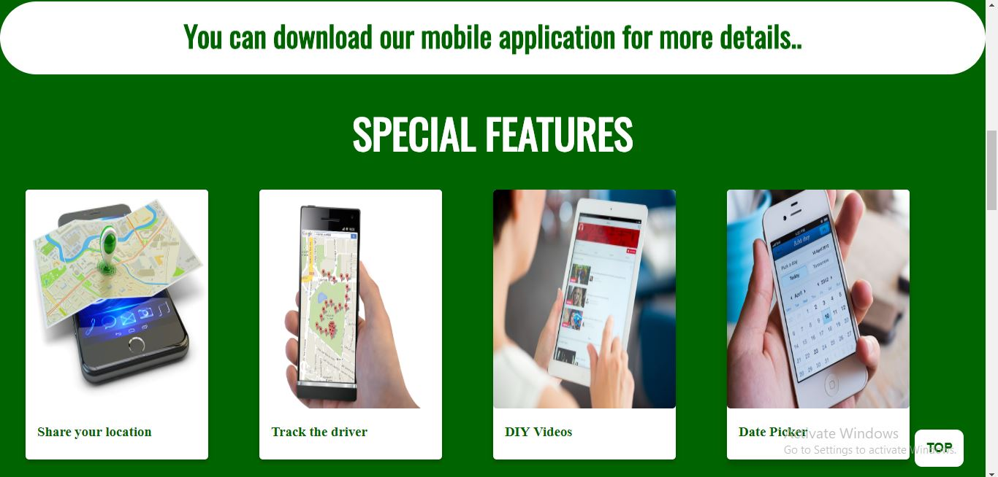

Figure 40 Web UI E

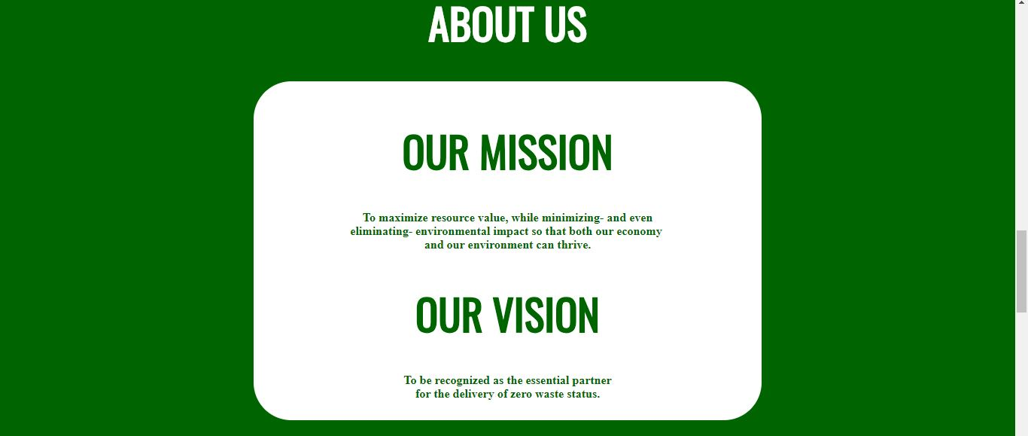

Figure 41 Web UI F

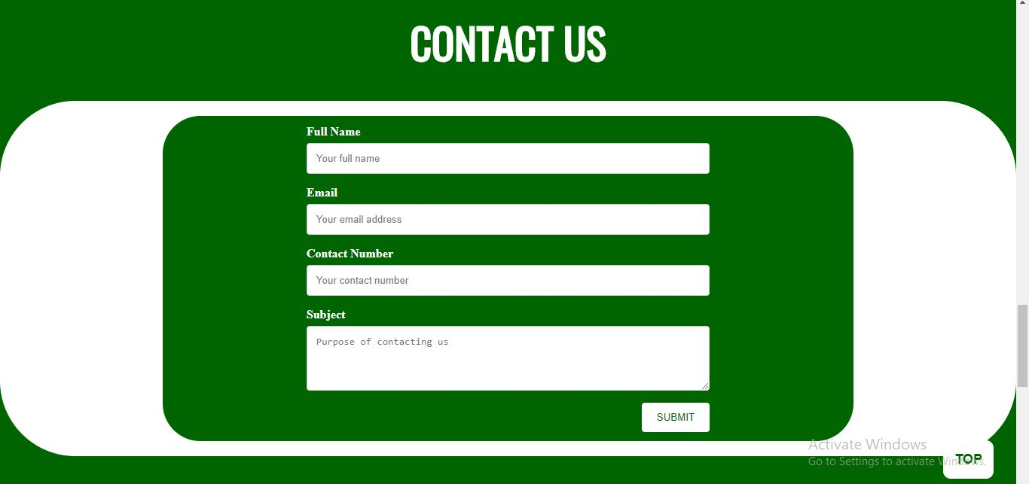

Figure 42 Web UI AG

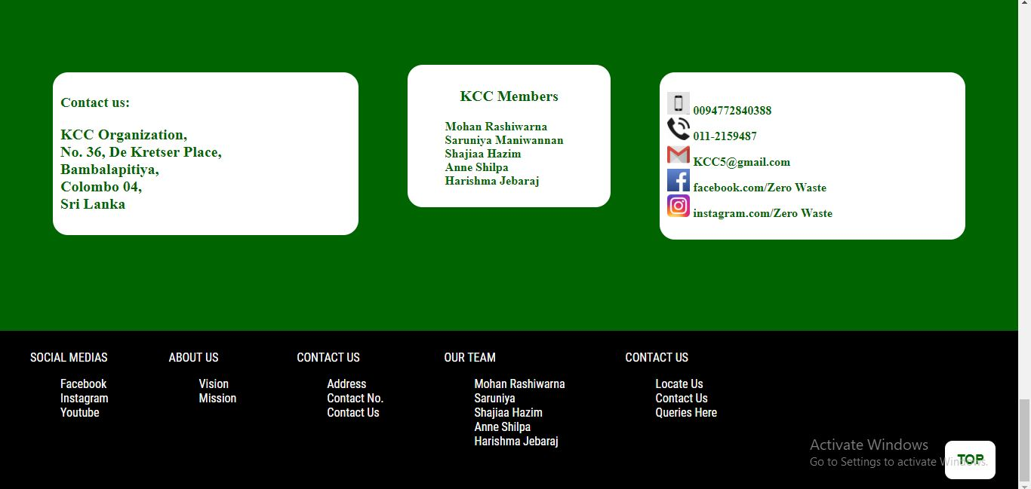

Figure 43 Web UI H

# CHAPTER 04

## Explanation of co-functionalities with evidence

**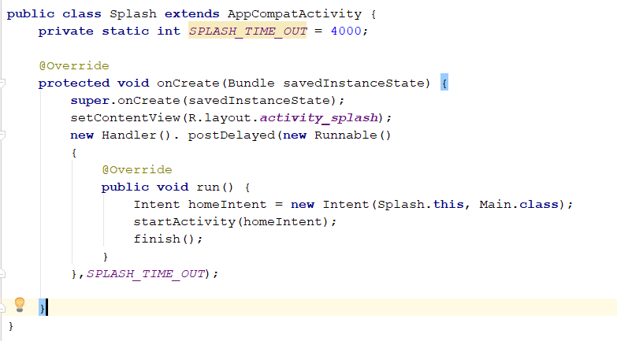Splash Page**

Figure 44 Splash code

It’s a particular screen on android that displays while the application is loading. In here **SPLASH\_TIME\_OUT = 4000** code used to set duration of wait. **onCreate** activity called when the activity is first created. **new Handler ()** usedto start the Main –Activity and close the splash screen after some seconds. Create an **Intent** that will start the Main-Activity.

**Build Dependencies**

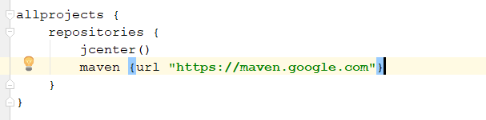We are using a version of Gradle lower than 4.1, so we instead to use this maven code.

Figure 45 Repositories code

The dependencies block configures the dependencies gradle need to use to build the project. This code adds android plugin for gradle version 2.3.0 as a class path dependency.

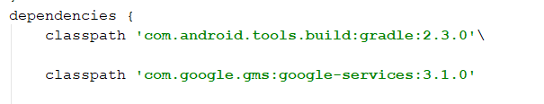

Figure 46 Class path code

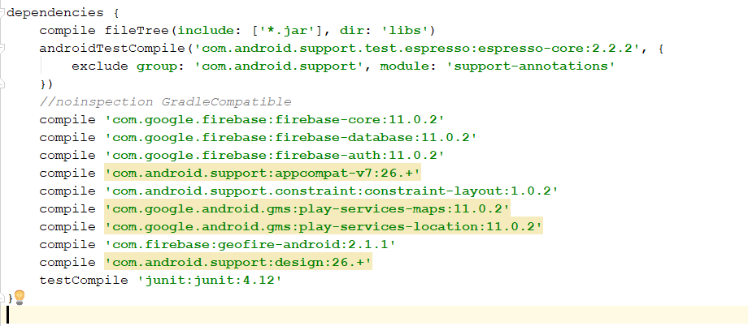

Figure 47 Compile

**Navigation Drawer**

This code is for Navigation drawer. Here we can set item as selected to persist highlight an close drawer when item is tapped.

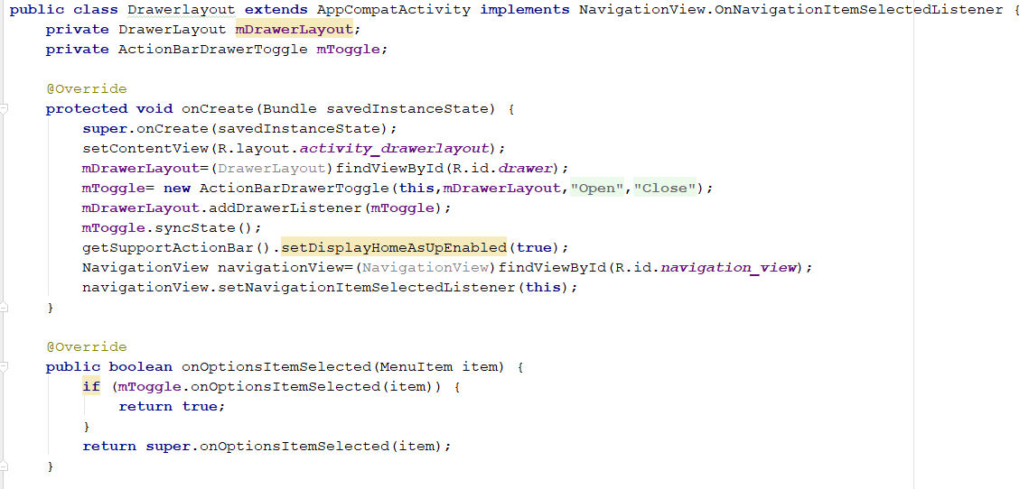

Figure 48 Navigation code

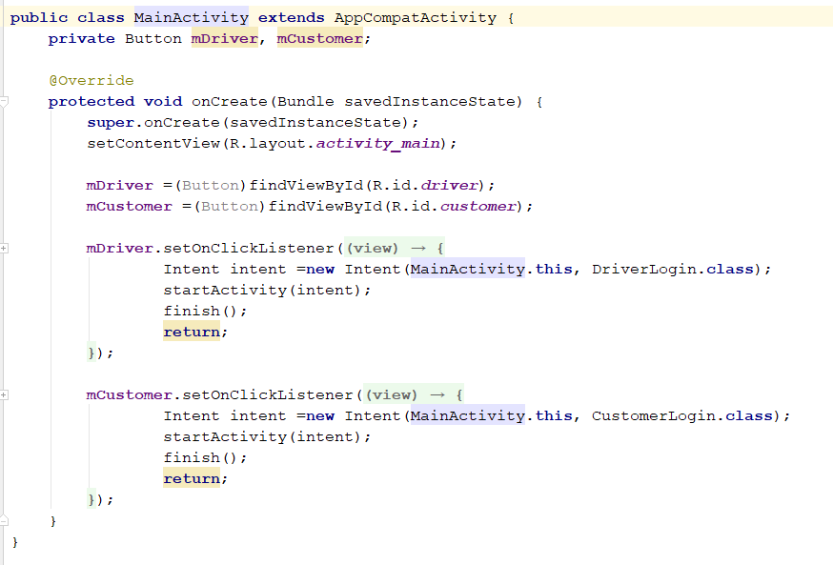**Main Activity**

Figure 49 Main Activity code

It is the main page that used to connect the login page for Driver and Customer. Create an **Intent** that will start the Driver Login and Customer Login Activity.

**Customer Login Page**

FirebaseAuth.getInstance ().getCurrentUser() returns the currently logged in user in firebase. The user which with whom the credentials made the login from the android emulator. If a user isn't signed in, getCurrentUser returns null. This is Sign in logic.

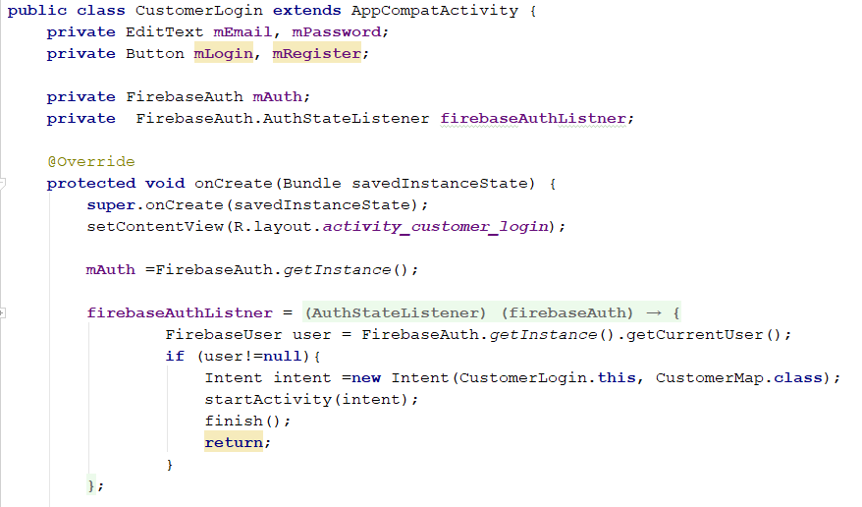

Figure 50 Customer Login 1

FirebaseAuthEmailExeption Represents the exception which is a result of an attempt to send an email via Firebase Auth.

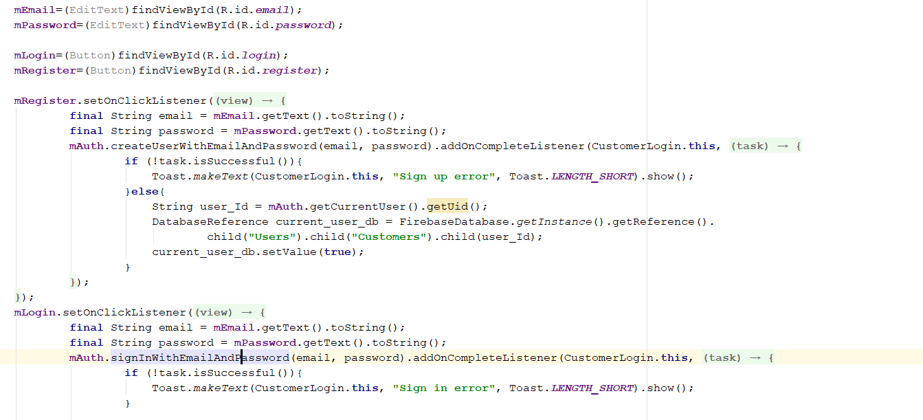

Figure 51 Customer Login 2

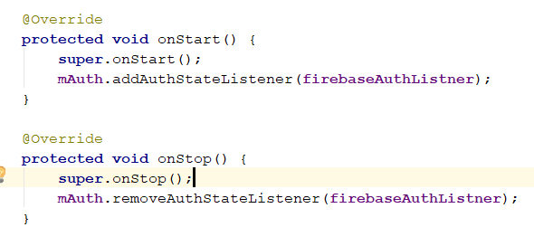

Figure 52 Customer Login 3

As same as for Driver Login Page.

**Customer Map Activity**

To use the Geocoding API, we registered our app project on the Google API Console and get a **Google API key** which can add to the app. Provides **Connectioncallbacks** that are called when the customer is connected or disconnected from the service. Used for receiving notifications when the location has changed. The methods are called if the **LocationListener**.

User can use the **Google API Client** object to access the Google APIs provided in the Google Play services library. The Google API Client provides a common entry point to Google Play services and manages the network connection between the user's device and each Google service.

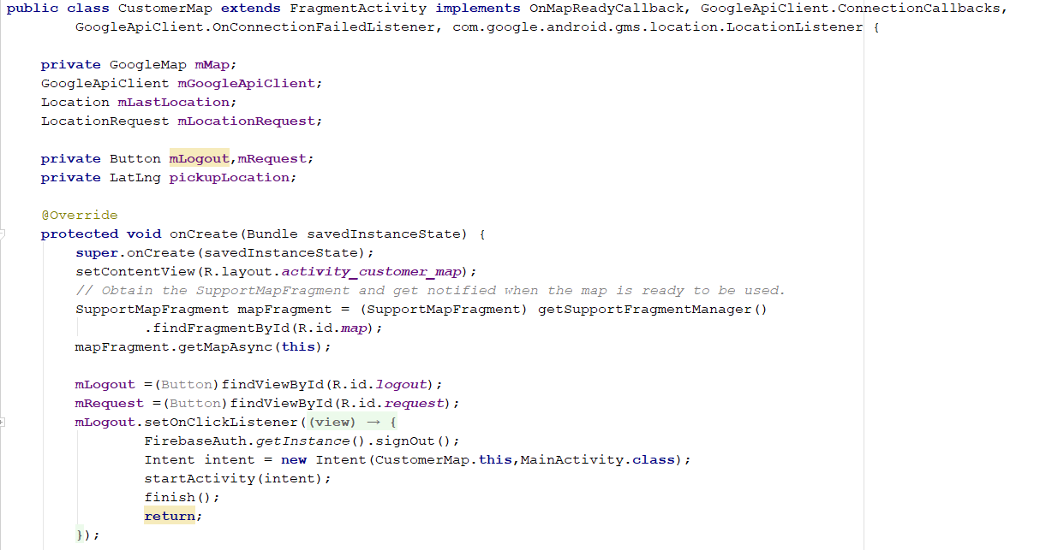

Figure 53 Customer Map OnCreate Method

**LatLng** is an immutable class representing a pair of latitude and longitude coordinates, stored as degrees. **Latitude** and **longitude** are in degrees.

This **mapFragment** is the simplest way to place a map in an application.

A Firebase reference represents a particular location in our Database and it can be used for reading data to that Database location. This class is the starting point for all Database operations. After initialized it with a URL, we can use it to read data, write data, and to create new **DatabaseReferences**. **Markers** indicate single locations on the map.

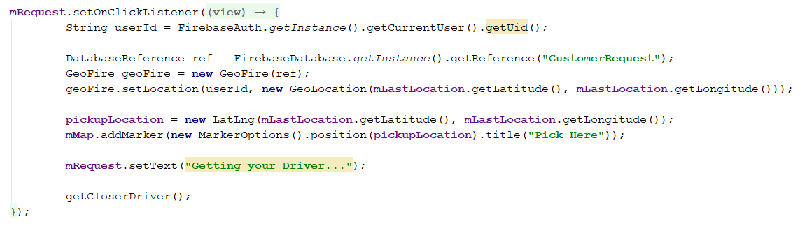

Figure 54 Customer Map GeoFire

The **Boolean** class wraps a value of the primitive type in an object. Returns true if and only if the argument is not null and is a Boolean object that represents the same boolean value as this object.

This interface is used as a method of being notified when an operation has been acknowledged by the Database servers and can be considered complete.

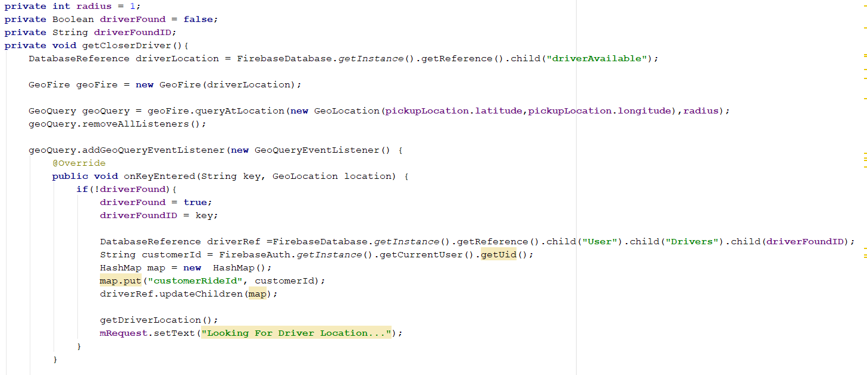

Figure 55 Customer Map Database

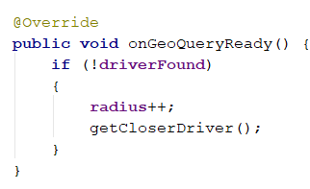

Figure 56 Customer Map radius

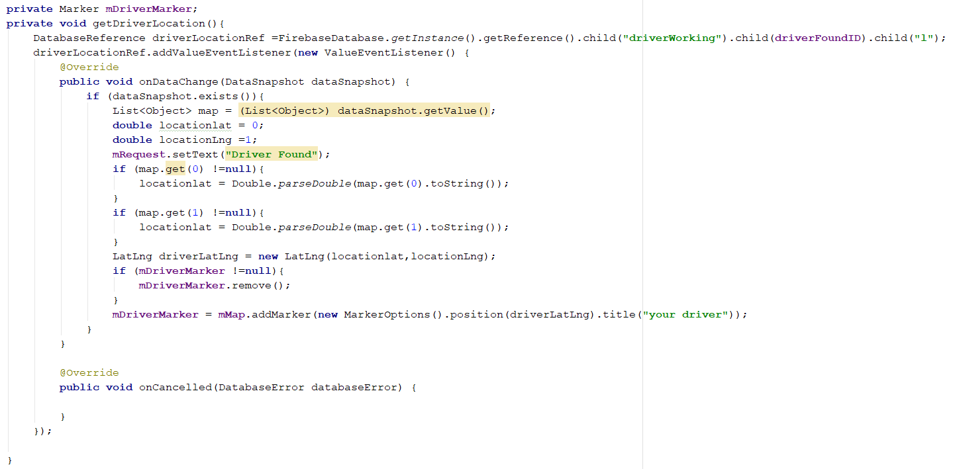

Figure 57

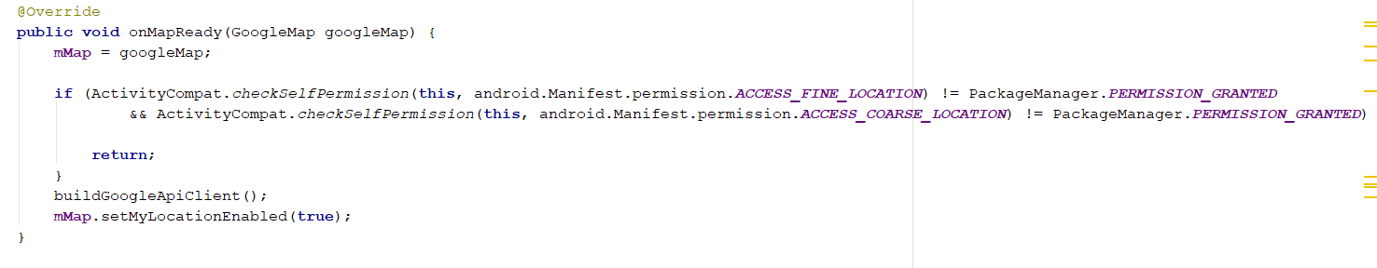

Figure 58

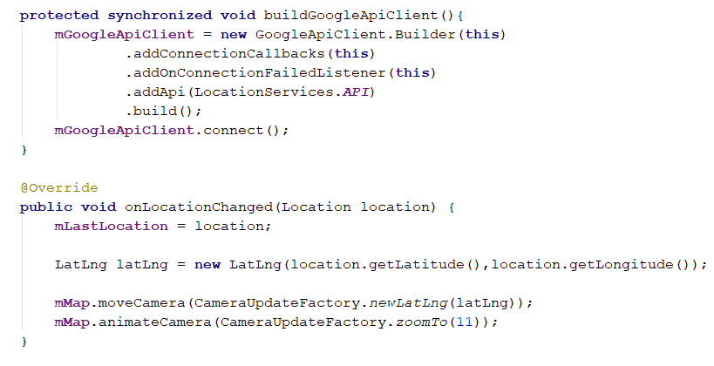

Figure 59

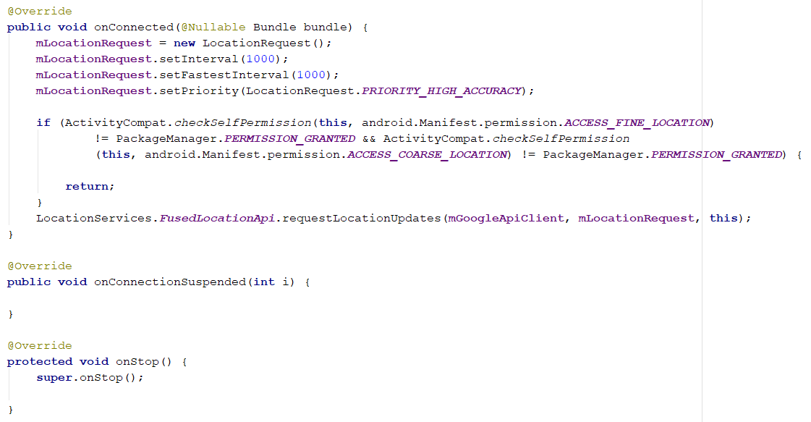

Figure 60

After create Google API Cloud Replace API google Map Key

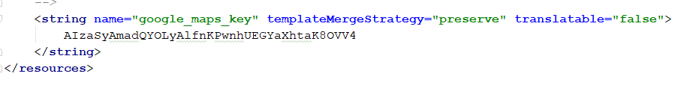

Figure 61

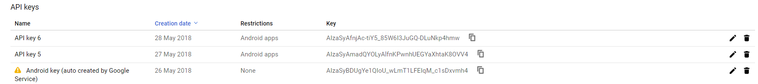

Figure 62

## Co functionalities with evidence for dynamic website

Purpose of this website is to advertise our mobile application. It’s a normal dynamic website.

Here I have used slideshow design. It’s just to attract the customer who is entering the website.

HTML code for the feature is mentioned below.

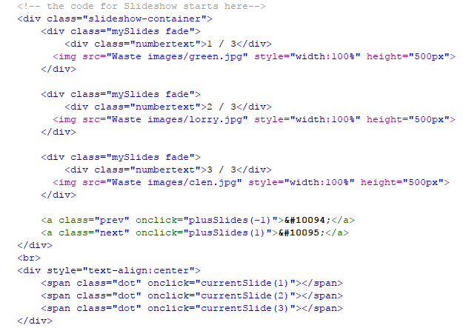

Figure 63 Web code A

Java script is important to make the slideshow function.

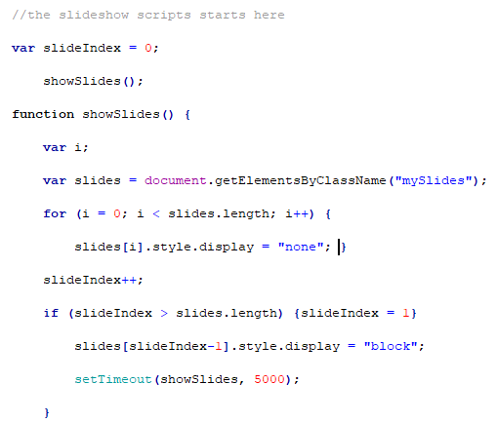

Figure 64 Web code B

Usually we connect java script with html script.

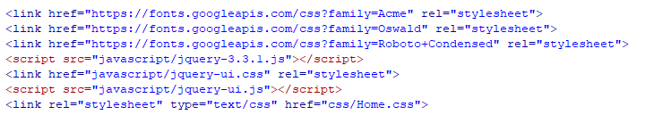

Figure 65 Web code C

And also I have inserted card containers

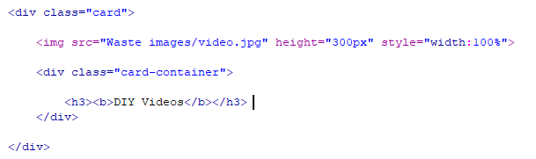

Figure 66 Web code D

Especially I have put a button which can move the cursor to the up. It is mentioned below.

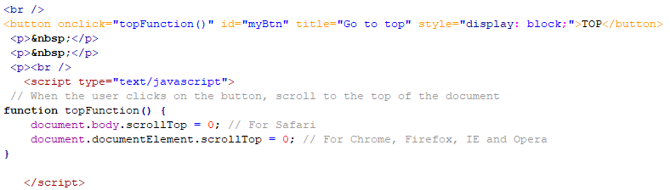

Figure 67 Web code D

# CHAPTER 05

## Testing

### Testing Methodology and Justification

What is testing?

Testing is a phase where it is checked whether the system is functioning properly. Testing can be done in various methods as given below:

**•Unit Testing**

Under unit testing each and every unit is being tested separately. The main purpose is to validate that each unit of the software as designed. Basically in the procedural programming a unit can be a function, individual program, module, etc.

**•Integration Testing**

However integration testing is quite different when compared to unit testing. It is because under integration testing two units are being tested at once in order to detect errors.

**•Incremental Testing**

Under incremental testing units are being integrated one or some at a time until all the units are being integrated.

**•System Testing**

Under system testing all the available units are being tested at once to detect errors.

**•Functional Testing**

This testing technique is undertaken mainly in order to check whether the units are functioning properly as required (whether working properly).

**•Acceptance Testing**

This testing technique is based upon a small concept. It is that if the customer requirements are met then the project would be accepted by the customers else the customers won’t accept it.

**•Regression Testing**

It is most commonly performed once some changes are made to the current system. All the portions of the program affected by the modifications must be re-tested.

If the functions are working properly it means that the testing had been done properly and the system will work smoothly.

**•White Box Testing**

White Box testing is performed by the programmer in order to find for syntax errors. It basically involves of evaluating coding practices, data flow as well as handling of errors within the system.

**•Black Box testing**

Black box testing is basically performed by the Quality control Engineers in order to determine the quality of the program. It is also known as a behavioral Testing. It is a method of testing where internal structure/ implementation as well as design of the items are tested is not known to the tester (tutorialspoint, 2016)

We used black box testing to test zero waste mobile app.,

Justification for black box testing

* Its efficient to use in our system
* Tester can be non-technical. so it’s an advantage to us.
* It helps us to identify vagueness and contradictions in functional specification
* Test cases can be designed as soon as the functional specifications are complete.
* Tests will be done from and users point of view Not of the designers. So we have to use the same interface to communicate with it as a user does.
* It can be designed immediately the completion of our system.
* These text cases are extremely difficult to be designed without clear specifications.
* Our customers don’t care whether all unit tests are passing. Probably they don’t even know what unit tests are.

### Test Plan

Table 3 Test Plan

|  |  |  |  |
| --- | --- | --- | --- |
| **Test ID** | **Test objective** | **Test Scenario** | **Expected Results** |
|  | Check Role based login option page | Options should display | Page should display |
|  | Select the role based login, whether ‘Am a driver’ or ‘Am a customer’ | Select “I am a driver” | login page should display |
|  | Select the role based login, whether ‘Am a driver’ or ‘Am a customer’ | Select  “I am a customer” | login page should display |
|  | Check the driver login whether it’s working with correct email and password | Type email: [driver@driver.com](mailto:driver@driver.com)  Password:123456 | Map UI should display |
|  | Check the customer login whether it’s working with correct email and password | Type email: [customer@customer.com](mailto:customer@customer.com)  Password:123456 | Map UI Navigation drawer should display |
|  | Check Login unauthorized access | Insert wrong email and password | Sign in error should display |
|  | Check the register | If not having an account click register to get registered | Login UI s should display for each role |
|  | Check the map | Click and see whether the map is getting displayed | Google map should display |
|  | Check the location | Click the location marker and check whether its showing your current location | Map should display with Mentioning your location |
|  | Test the system in different model phones | Check in huawei, Samsung and nokia phones | Must work in all model phones |
|  | Run the GPS system in several devices like PC and laptops | Check it whether it’s working | PC should access GPS |
|  | Check the Payment (PayPal) | Insert userId and Password and check whether its getting paid | Paid successfully message should display |
|  | Check the firebase | Check the fire base whether data getting saved | Saved successfully |
|  | Check logout | Click the button logout | You have logout message should display |

### Test Cases

Table 4 Test Case 1

|  |  |
| --- | --- |
| Test Case | **Test 1** |
| Test objective | Check Role based login option page |
| Test data | Options should display |
| Expected result | Page should display |
| Actual result | Screenshot_2018-05-28-18-52-21.png |
| Conclusion | Working as expected |

Table 5 Test Case 2

|  |  |
| --- | --- |
| Test Case | **Test 2** |
| Test objective | Select the role based login, whether ‘I Am a driver’ or ‘I Am a customer’ |
| Test data | Select “I am a driver” |
| Expected result | Login page should display |
| Actual result | Screenshot_2018-05-28-18-52-21.png |
| Conclusion | Working as expected |

Table 6 Test Case 3

|  |  |
| --- | --- |
| Test Case | **Test 3** |
| Test objective | Select the role based login, whether ‘Am a driver’ or ‘Am a customer’ |
| Test data | Select “I am a customer” |
| Expected result | Login page should display |
| Actual result | Screenshot_2018-05-28-18-52-21.png |
| Conclusion | Working as expected |

Table 7 Test Case 4

|  |  |
| --- | --- |
| Test Case | **Test 4** |
| Test objective | Check the driver login whether it’s working with correct email and password |
| Test data | Type email: [driver@driver.com](mailto:driver@driver.com)  Password:123456 |
| Expected result | Map UI should display |
| Actual result | Screenshot_2018-05-28-18-52-21.png |
| Conclusion | Working as expected |

Table 8 Test Case 5

|  |  |
| --- | --- |
| Test Case | **Test 5** |
| Test objective | Check the customer login whether it’s working with correct emial and password |
| Test data | Type email: [customer@customer.com](mailto:customer@customer.com)  Password:123456 |
| Expected result | Map UI Navigation drawer should display |
| Actual result | Screenshot_2018-05-28-18-52-21.png |
| Conclusion | Working as expected |

Table 9 Test Case 6

|  |  |
| --- | --- |
| Test Case | **Test 6** |
| Test objective | Check Login unauthorized access |
| Test data | Insert wrong email and password |
| Expected result | Sign in error should display |
| Actual result | Screenshot_2018-05-28-18-52-21.png |
| Conclusion | Working as expected |

Table 10 Test Case 7

|  |  |
| --- | --- |
| Test Case | **Test 7** |
| Test objective | Check the register |
| Test data | If not having an account click register to get registered |
| Expected result | Login UI s should display for each role |
| Actual result | Screenshot_2018-05-28-18-52-21.png |
| Conclusion | Working as expected |

Table 11 Test Case 8

|  |  |
| --- | --- |
| Test Case | **Test 8** |
| Test objective | Check the map |
| Test data | Click and see whether the map is getting displayed |
| Expected result | Google map should display |
| Actual result | Screenshot_2018-05-28-18-52-21.png |
| Conclusion | Working as expected |

Table 12 Test Case 9

|  |  |
| --- | --- |
| Test Case | **Test 9** |
| Test objective | Check the location |
| Test data | Click the location marker and check whether its showing your current location |
| Expected result | Map should display with Mentioning your location |
| Actual result | Screenshot_2018-05-28-18-52-21.png |
| Conclusion | Working as expected |

Table 13 Test Case 1 0

|  |  |
| --- | --- |
| Test Case | **Test 10** |
| Test objective | Test the system in different model phones |
| Test data | Check in huawei, Samsung and nokia phones |
| Expected result | Must work in all model phones |
| Actual Result | Only working in Samsung model phones |
| Conclusion | Not working as expected |

Table 14 Test Case 1 1

|  |  |
| --- | --- |
| Test Case | **Test 11** |
| Test objective | Run the GPS system in several devices like PC and laptops |
| Test data | Check it whether it’s working |
| Expected result | PC should access GPS |
| Actual Result | PC could not access GPS |
| Conclusion | Not Working as expected |

Table 15 Test Case 1 2

|  |  |
| --- | --- |
| Test Case | **Test 12** |
| Test objective | Check the Payment (PayPal) |
| Test data | Insert userId and Password and check whether its getting paid |
| Expected result | Paid successfully message should display |
| Actual Result | Message displayed |
| Conclusion | Working as expected |

Table 16 Test Case 1 3

|  |  |
| --- | --- |
| Test Case | **Test 13** |
| Test objective | Check the firebase |
| Test data | Check the fire base whether data getting saved |
| Expected result | Saved successfully |
| Actual result | 2.PNG3.PNG |
| Conclusion | Working as expected |

Table 17 Test Case 1 4

|  |  |
| --- | --- |
| Test Case | **Test 14** |
| Test objective | Check logout |
| Test data | Click the button logout |
| Expected result | You have logout message should display |
| Actual result | Screenshot_2018-05-28-18-52-21.png |
| Conclusion | Working as expected |

### Test Conclusion

As we did the plan for the testing’s we were able to do most of them successfully. There are 14 test plans mentioned above. Here we have given down a brief explanation about the whole 14 test cases.

A limited number of tests, order as well as more resent ones are described in detailed below. The first nine pertain to intelligibility tests, ordered from tests based on how the system working perfectly. Test 10, 11 and 12 describe three prosody tests. And test no 13 related to overall quality of tests. Finally test 14 describe our system’s last part. Tests were included that have been frequently used, or were developed specifically, for evaluating synthesis outputs.

## User Manual

* Waste Management System is collecting, transporting, converting the remaining of anything into some useful product or disposing the collected waste in such a way that is not harmful to the environment. This system is intended for individuals who are stuck in an unfortunate situation to arrange their home waste things, human exertion, time and cost will be avoided with our present innovations. Firstly you have to install the app.

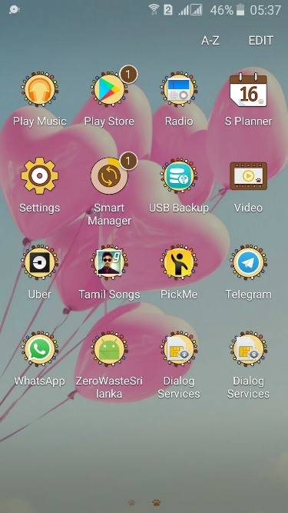

* Then comes the welcome page once you have installed it successfully. There you will be able to see two buttons saying I am driver and I am a customer.
* If you are a customer then you’re supposed to click the customer button or else if you are a driver you will have to click on the driver button.
* Once you click on the customer button it will lead you to a page where you will be asked to fill your e-mail Id, password, login and register.
* If you are a new member to the system and your willing to register, so you will have to give your e-mail Id and password and register yourself an account.
* Once the registration process is done it will take you to the customer page automatically. There you can find payment, settings, help, DIY (Do it yourself), logout, schedule. Under payment you can choose both ready cash and online (PayPal) to do the payment procedures. From the setting you can create your own profile where you will be asked to fill you name, e-mail, address and phone no and then have to click on the save button, once creating procedure is done, then you will become a member. If you need any help you can choose the help button to solve the problem. Under schedule you can choose when to dispose garbage, categories and the weight of the garbage.
* Once the registration and creating profile works are done you will become a member. So you can login to the system anytime you want. Once you’re logged in, the same procedure to follow as I have mentioned above under register.
* Then you have a button called map where you have to fix your location by the help of GPS for us to identify your place to collect the garbage.

# CHAPTER 06

## Limitation

* Throughout this project Waste disposal indicator did not specifically report on liquid, gaseous and hazardous wastes, although some potentially hazardous waste is included in estimates of solid waste disposed of to landfills.
* Please note that the results presented by this indicator are, therefore, indicative estimates rather than statistically significant measurement.
* The indicator did not measure activities aimed at minimizing waste and increasing resource efficiency, such as improvement to production methods.
* Such collection schemes should be supported by a value-based conception of waste which indicates the resource value of materials, along with their potential environment impact (e.g. hazardous waste) or preferred treatment methods (e.g. recyclable).

## Lesson learned report

The purpose of this lesson learned document of Zero Waste Management system is to show out the lesson learned in a format to be referred easily. It will be useful for the project managers for handling future projects regarding waste management system. Lessons learned is to bring together any insights gained during a project that can be usefully applied on future projects.

Table 18 Lesson learned report

|  |  |  |  |  |
| --- | --- | --- | --- | --- |
| **Category** | **Issue Name** | **Problem/**  **Success** | **Impact** | **Recommendation** |
| Procurement Management | Project Requirement | Project Manager interfered in all most all of the process | All requirements were included in the project proposal. Project modification was not necessary because the process were supervised by project manager | Project Manager should be engaged in all the processes as in this situation |
| Human Resource Management | Award Plan | There was no plan for providing awards and measuring exactly how much work has been done but the whole group worked as a team, helping each other. | Working as a team reduced the pressure of the team but a measurement for how much a person has done seems to be questionable as to give proper recognition and award | The project manager should find out a way to measure the amount one person has worked |
| Scope Management | Scope Creep | The functionalities kept on adding throughout the development. | During development phase as team made few tests on the system and found out to add additional features to make the system more feasible | A complete plan should be discussed and carried out as to what the features are expected from the system |
| Quality Management | Software Application | Tests were done successfully but the team is not sure on how the users would feel about the system features and UI design | Led this the team management to add more features and also the UI design of the system not seemingly to impress the team developers even led to conflicts between team members | Should have a well prepared UI design accepted by all team members and limited amount of well-planned features |
| Risk Management | User satisfaction and the market value of the system | There is a problem in considering users satisfaction because of the UI designs and features and what would be the market value of a system because it’s a new idea | The team doesn’t know and not sure about is it profitable to invest money and time and effort in doing the system as the customers would love it or not or will they get adapted to the new system from the usual one | The team should know the scope and the market value and should also ensure whether the users would love it to use by discussing. |

## Future Recommendation

* Weight sensor- It is used to calculate the weight of the total waste percentage in the bin and sends the information to the management. It will show the up to date information to the authorities the level of garbage present in the bin.
* IR Sensor - Infrared sensors will be able to detect or emit IR radiation to scan the surrounding area. They are capable of amount of that the object emitting and they have the ability to detect the motion of the objects. All the objects which have a temperature greater than absolute zero possess thermal energy and sources of infrared radiation as a result. Using the IR sensor in the smart bins it can pass the information to our management when the wastage is over flowing it indicate by some notification and make a little noise until they squash the bin.
* Photo electronic sensor-Photo electronic sensor are used to detect the type of the object which are inside the bin like metals or nonmetals. It can detect the size and the type of the object by focusing a light on it. Through this the management can get information if there is any electronic item is been misplaced inside the bin. They can immediately come to know about it. Using this sensor our management can see the clear outline representation of the object. So, by this information they can easily remove the electronic in the different category bins.
* Change the system of user’s authentication and atomic lock of bins which would help in securing the bin from any kind of damage

# CONCLUSION

Garbage Management is a big issue for everyone to need action across it immediately. Our most promising alternatives are waste reduction, keep the cities clean and healthy. We have introduced an application based on waste management system over to make the users throw their litters in an appropriate way and on time, which brings up time consumption and healthy environment. The system is able to monitor the garbage level through a real time indicator in a trashcan at any given time. Avoid the overflow of garbage by notifying the collector via an SMS and give the precise location with the help of technology (GPS) we can guide the garbage trucks in selecting the shortest path for garbage collection. The system provides an efficient and effective way of garbage collection, it is possible to achieve a more efficient system. Our idea of “waste management system”, mainly concentrates on Monitoring the waste management, providing a smart technology for waste system, avoiding human intervention, reducing human time and effort and which results in healthy and waste ridden environment. Also a website has been launched by our organization in order to give a brief description for the users to understand about our app and to make it user friendly. By connecting with us, the user can dispose their garbage without causing any problem to the users and to the environment.

## Strength:

1. Our app is very user-friendly.
2. We have a good navigational structure
3. Data forms are easy to feed data
4. Proper tables created in SQL database.
5. Solving big issues in a short timeframe all through our project that demonstrated our liveliness would lead our undertaking project achievement.
6. We had a strong leadership which is important with the team. This doesn’t imply that the leader of our group needs to bully the team to maintain control, where as she did this by defining category or roles to each person.
7. We got relevant ideas and samples through internet which helped us in many to complement most of the tasks.
8. Our vision, mission, goals and objectives are clearly mentioned in a simpler way.

## Weakness:

1. Certain requirements lack in functionalities
2. Lack of communication. Communication is a vital key building and implementing their roles to the project. We had a bad communication among the team stuffs like absence of thoughts for individuals and requirements of building the project.
3. Highly Comparative surroundings without clear and defined group. We didn’t have a clear idea about the projects destination and the solving methods. No piece of information prompts nowhere.
4. Time management wasn’t enough to do as we expected.
5. We didn’t make many efforts to talk to with many people to ask about their feedbacks and advices to develop it.
6. Got so many errors throughout the developing of the app. Took a lot of time and patience to sit and correct them one by one.

### Enhancement

There are several future works and improvements for the proposed system,

1. We will change the system of user’s authentication and atomic lock of bins which would help in securing the bin from any kind of damage or theft.
2. Battery supported smart bins I would propose this as a feature for future development.
3. Inclusion of the control room will effectively help monitor the garbage level for the management.
4. Weight sensor will used to calculate the weight of the total waste percentage in the bin and sends the information to the management. It will show the up to date information to the authorities the level of garbage present in the bin.

# REFERENCES

Waste Management Survey. 2018. Waste Management Survey. [ONLINE] Available at: <https://www.surveymonkey.com/r/6BYQXR2>.[Accessed 10 April 2018].

HTMLForms.2018. HTMLForms.[ONLINE]Available at: <https://w3schools.com/html/html_forms.asp>. [Accessed 13 April 2018].

tutorialspoint.com. 2018. Agile Testing Methodologies. [ONLINE] Available at: <https://www.tutorialspoint.com/agile_testing/agile_testing_methodologies.htm>. [Accessed 24 May 2018].

Environment Foundation (Guarantee) Limited.. 2018. Status of Waste Management in Sri Lanka - Environment Foundation (Guarantee) Limited.. [ONLINE] Available at: <http://efl.lk/status-waste-management-sri-lanka/>. [Accessed 25 March 2018].

Android Material Design App Templates free resources for Sketch - Sketch App Sources - Page 1. 2018. Android Material Design App Templates free resources for Sketch - Sketch App Sources - Page 1. [ONLINE] Available at: <https://www.sketchappsources.com/tag/android.html>. [Accessed 13 April 2018].

tutorialspoint.com. 2018. Android Login Screen. [ONLINE] Available at: <https://www.tutorialspoint.com/android/android_login_screen.htm>. [Accessed 27 April 2018].

Sign in - Google Accounts. 2018. Sign in - Google Accounts. [ONLINE] Available at: <https://console.firebase.google.com/?pli=1>. [Accessed 28 April 2018].

AndroidHive. 2018. Android adding SMS Verification Like WhatsApp - Part 1. [ONLINE] Available at: [https://www.androidhive.info/2015/08/android-adding-sms-verification-like-whatsapp-part-1/.](https://www.androidhive.info/2015/08/android-adding-sms-verification-like-whatsapp-part-1/) [Accessed 02 May 2018].

GitHub. 2018. The world’s leading software development platform · GitHub. [ONLINE] Available at: <https://github.com/>. [Accessed 04 May 2018].

Real-time Asset Tracking. 2018. Real-time Asset Tracking. [ONLINE] Available at: <https://codelabs.developers.google.com/codelabs/realtime-asset-tracking/index.html?index=..%2F..%2Findex#0>. [Accessed 06 May 2018].

Google Cloud. 2018. Google Maps Platform - Geo-location APIs | Google Maps Platform | Google Cloud. [ONLINE] Available at: <https://cloud.google.com/maps-platform/>. [Accessed 06 April 2018].

TO THE NEW BLOG. 2018. PayPal SDK Integration in Android Applications | TO THE NEW Blog. [ONLINE] Available at: <http://www.tothenew.com/blog/paypal-sdk-integration-in-android-applications/>. [Accessed 16 May 2018].

# APPENDIX

## PLANNED & ACTUAL GANTT CHART

### Estimated Gantt chart

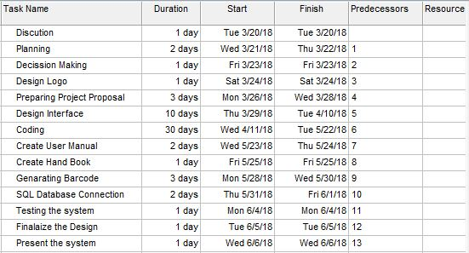

Figure 68

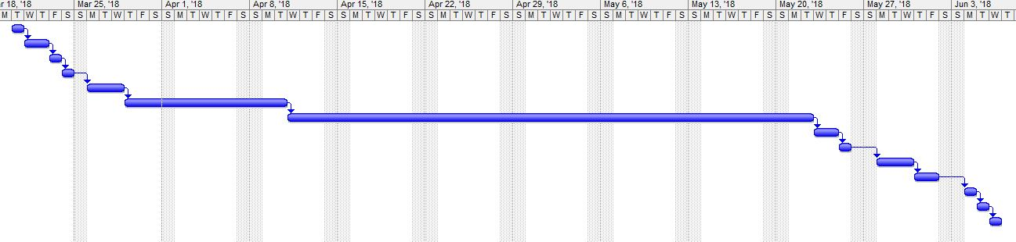

Figure 69

### Actual Gantt chart

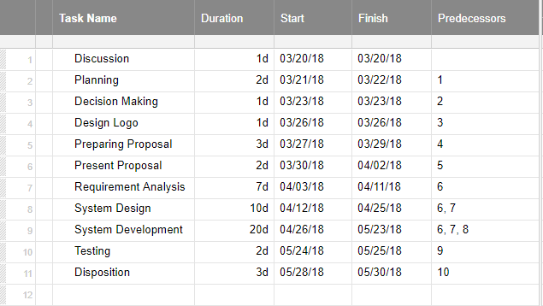

Figure 70

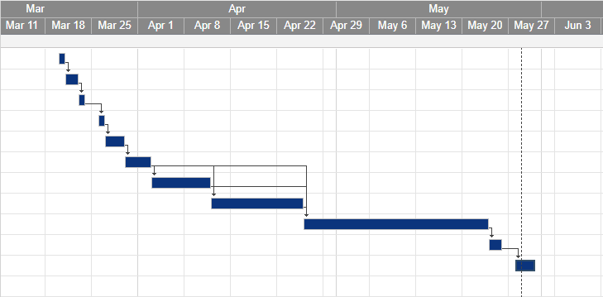

Figure 71

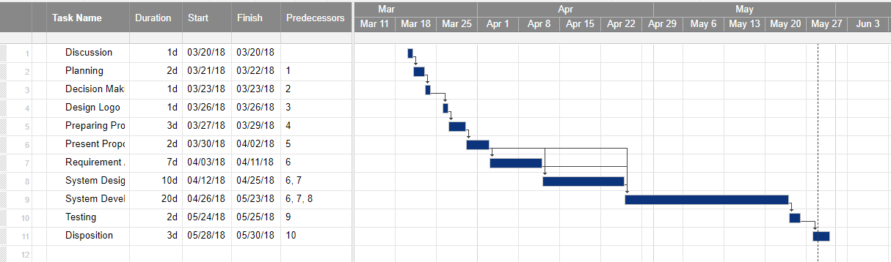

Figure 72

A Gantt chart is a horizontal bar chart that visually represents a project plan over time. Actual Gantt shows it clearly that we took lesser time to finish the project before the estimated time which has been precisely mentioned above as the estimated Gantt chart.

Under estimated Gantt chart we needed grace time as the dependency level is high. Only if we design the interface we will be able to do the coding parts. So we estimated like 10 days to do so. As we estimated we took like 10 days’ time to do the system design in the actual way too.

System designing was depended on the present proposal and requirement analysis which took like 7 days to complete it successfully. And the rest things on the top mentioned about the in actual Gantt chart took less times like inside 1 -3 days per task to be done. System development took gracious times like 20 days as it was depended on present proposal, requirement analysis and system design as well.

And as it was done by one person we needed such time to complete the specific task. The rest, testing and disposition took like 2-3days to complete as all our team members worked to complete the project before the dead line.

### Requirement gathering evidences

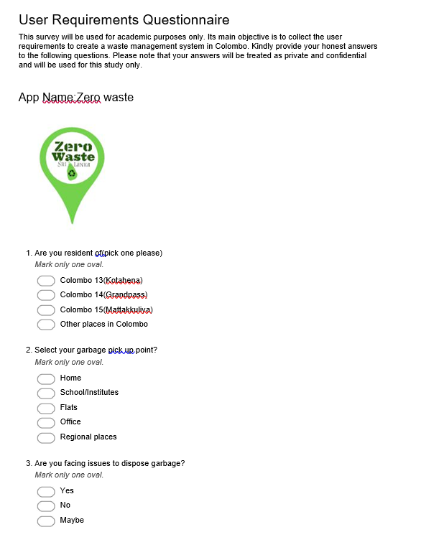

Figure 73 Requirement gathering survey

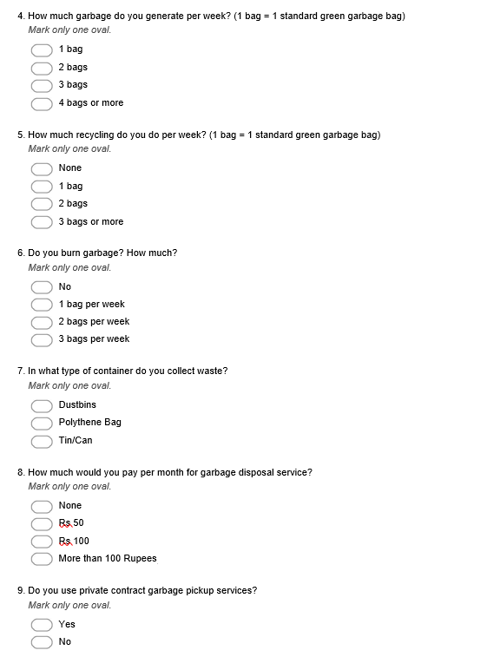

Figure 74 Requirement gathering survey

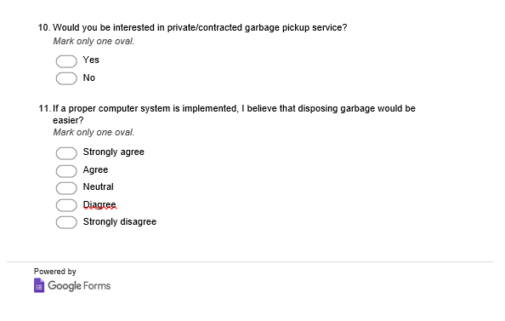

Figure 75 Requirement gathering survey

## Requirement Gathering Evidences

Waste Management undertakes customer satisfaction surveys. Our research carries these out onsite with customers. We are responsible for undertaking all fieldwork and analyzing the results and feedback. This ensures that all feedback is as objective as possible. In total, 50 people were asked to fill the user requirements and we were able to get 45 responses.

Customers were surveyed and asked to feedback on their opinion for our new waste management system.

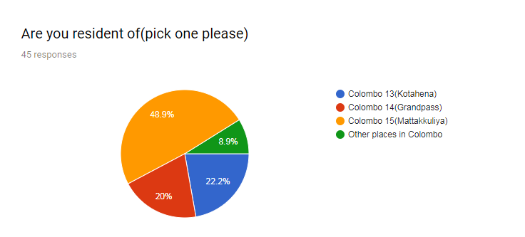

Figure 76

The graph above shows the majority of people are from Mattakkuliya which is 48.9%. 45 people responded for the particular question. And a very few are from other places in Colombo which is 8.9%. So we’ll be having to work more under this area and may be having branch nearby to drop down the waste would be done once this works out successfully.

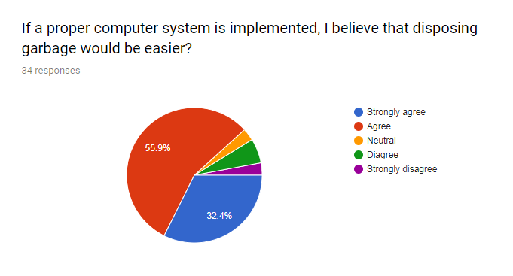

Figure 77

Customers are asked to mark their satisfaction levels regarding a computer system implementation, so through this disposing garbage would be easier. There are from 1 to 5, point 1st one with being ‘Strongly agree’ and 5th one with being ‘Strongly disagree’. 55.9% out of 100% managed to choose agree which shows that they are basically knowledge able with computer and 32.4% of them have responded saying strongly agree which show their confident level in using computer system and their capable to handle. None of them have chosen either neutral, disagree and strongly disagree.

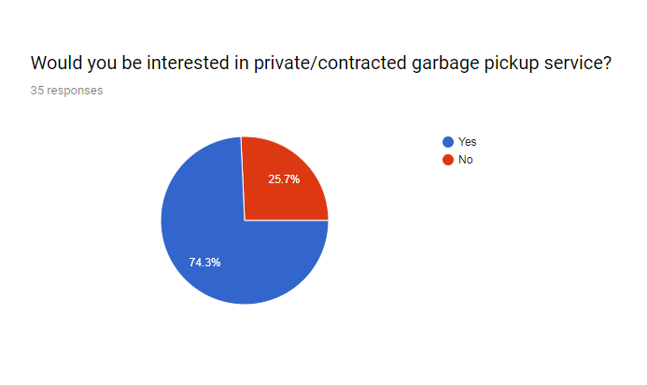

Figure 78

As the above image, the most number of percentage marked saying yes that they are interested in private or contracted garbage pickup service which has 74.3%. 25.7% took time to say no that they are not interested in such an idea. Which gives us a proper idea that clearing garbage process is not been done properly so our service can play a vital role if we execute so.

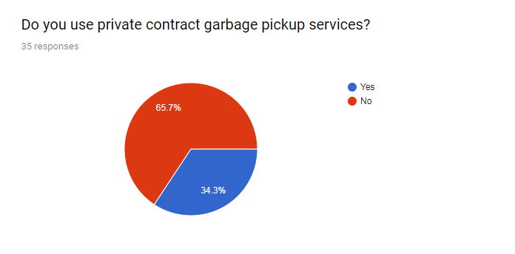

Figure 79

Over here only 35 people out of 50 were managed to respond for this particular question. 65.7% of people doesn’t use a private contracted garbage pickup service and 34.3% of them uses a private garbage pickup service. So which clearly show only a few have showed interest toward such an idea and which is we will have more work to make it better, much user-friendly and make users choose us to work with.

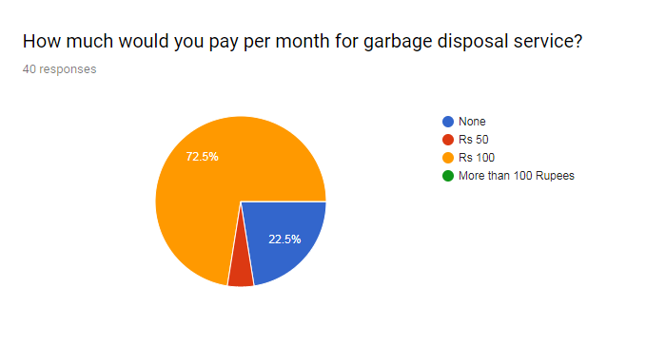

Figure 80

Customers are asked to rate their overall satisfaction on the amount they will to pay per month for garbage disposal service. 72.5% of them have choose Rs 100 and 22.5% says none. So per month grabbing Rs.100 from each member would be the satisfied decision from this particular feedback.

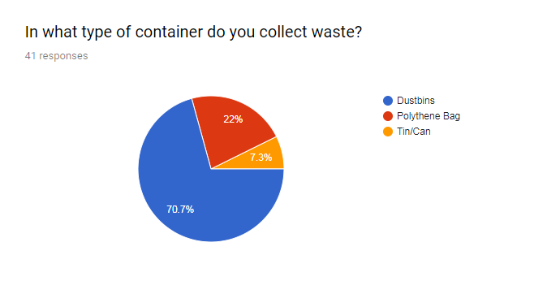

Figure 81

Most number of people, 70.7% of them collect their waste by using a dustbin and few, 7.3% of them uses tins or cans to collects their wastes.

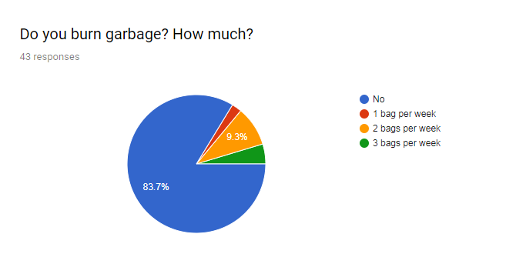

Figure 82

The graph above shows clearly that most of the people doesn’t burn their garbage. Obviously, people around Colombo are mostly shelters in flats or house without garden. Next thing would be not enough time to allocate to do all this works.

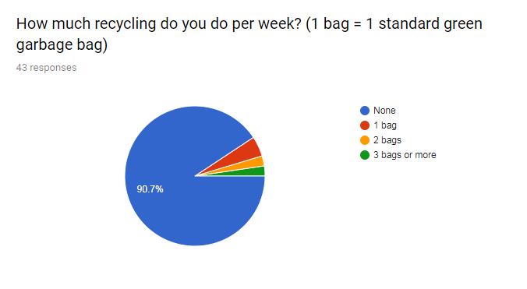

Figure 83

43 people managed to respond for this particular question. 90.7% doesn’t recycle their waste. So through our management we will help to recycle and let the users know the benefits of recycling. And we have a video attached with our app saying DIY(“Do It Yourself) which would help to give a clear idea about recycling plans and ways.

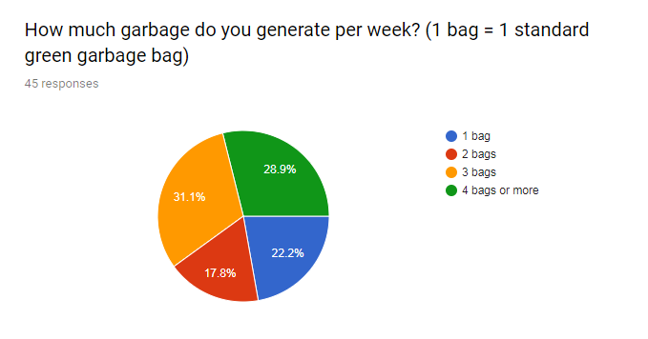

Figure 84

As the above image shows the highest percentage 31.1% of people generate 3 bags per week 28.9% generates 4 bags or more, 22.2% generates just one bag only. Which shows that when people already is full with one it’s not been collected on time so it’s been overloaded for week. We would promise to take on time and help you keep your surroundings clean as possible.

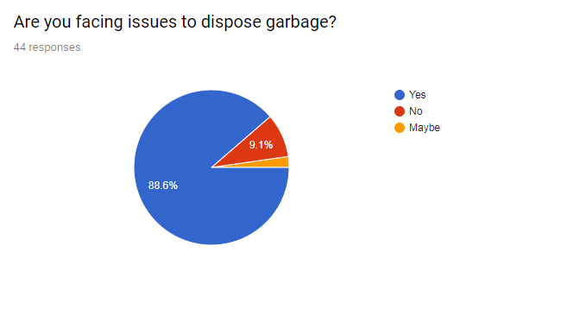

Figure 85

88.6% of people are facing issues to dispose garbage and only a few 9.1%of them have marked saying no, they does not have any issues. We, our mangement can clear out all your issues and problesm faced with garbages around you.

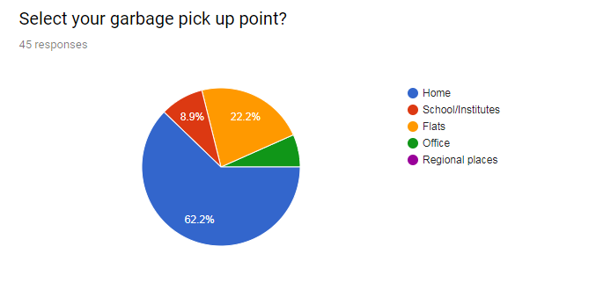

Figure 86

This above graph show the garbage pickup point is mostly from homes. 62.2% of people have chosen home as the pickup point. 22.2% are flats and 8.9% are schools and institutes. So sending vehicles to house areas will be the most.